SSVPS Bapusaheb Shivajirao Deore College of Engineering, Dhule

Department of Electronics and Telecommunication Engineering

Time Table | 2024-25 Even Semester W.e.f. 03/03/2025

T.Y. B.Tech.

321- CR-13

4:30 - 5:30

Day↓Time→ 10:45 - 11:45

11:45 - 12:45 12.45 -1.15

1:15 - 2:15

2:15 - 3:15

3.15 - 3.30

3:30 - 4:30

MP-II -E1 VST - Lab-42

MP-II -E2 VRH- Lab-43

Mon

AWP-ABP

E&SD-PSK

R

ESD

R

DC&MPMC -E3 PSK - Lab-38

DC&MPMC -E4 DRB - Lab-44

DC&MPMC -E1 MVJ - Lab-38

MP-II -E2 VRH - Lab-42

Tue

Wed

Thr

Fri

ESD

E

C

E

S

S

E

C

E

S

S

DC - PSK

MPMC(Tu)

DRB

DC&MPMC-E3 DRB - Lab-44

MP-II-E4 HYB - Lab-43

MP-II -E1 VST - Lab-42

PE-3 MPMC -

DRB

DC&MPMC - E2 VRH - Lab-44

MP-II-E3 ABP - Lab-43

DC&MPMC -E4 PSK - Lab-38

OE-2 IoT&I

4.0 - MVJ

E&SD-PSK

AWP-ABP

DC&MPMC -E1 VRH - Lab-44

DC&MPMC -E2 MVJ - Lab-38

MP-II-E3 ABP- Lab-42

OE-2 IoT&I

4.0 - MVJ

PE-3 MPMC

DRB

DC(Tu)- MVJ

E&SD-PSK

AWP-ABP

MP-II-E4 HYB - Lab-43

OE-2 IoT&I 4.0

LG Meeting and

Contact Time

DC - PSK

DC - MVJ

ESD

- MVJ

IoT&I 4.0(Tu)-

MVJ

PE-3 MPMC -

DRB

Sat

AWP(Tu)-ABP

X

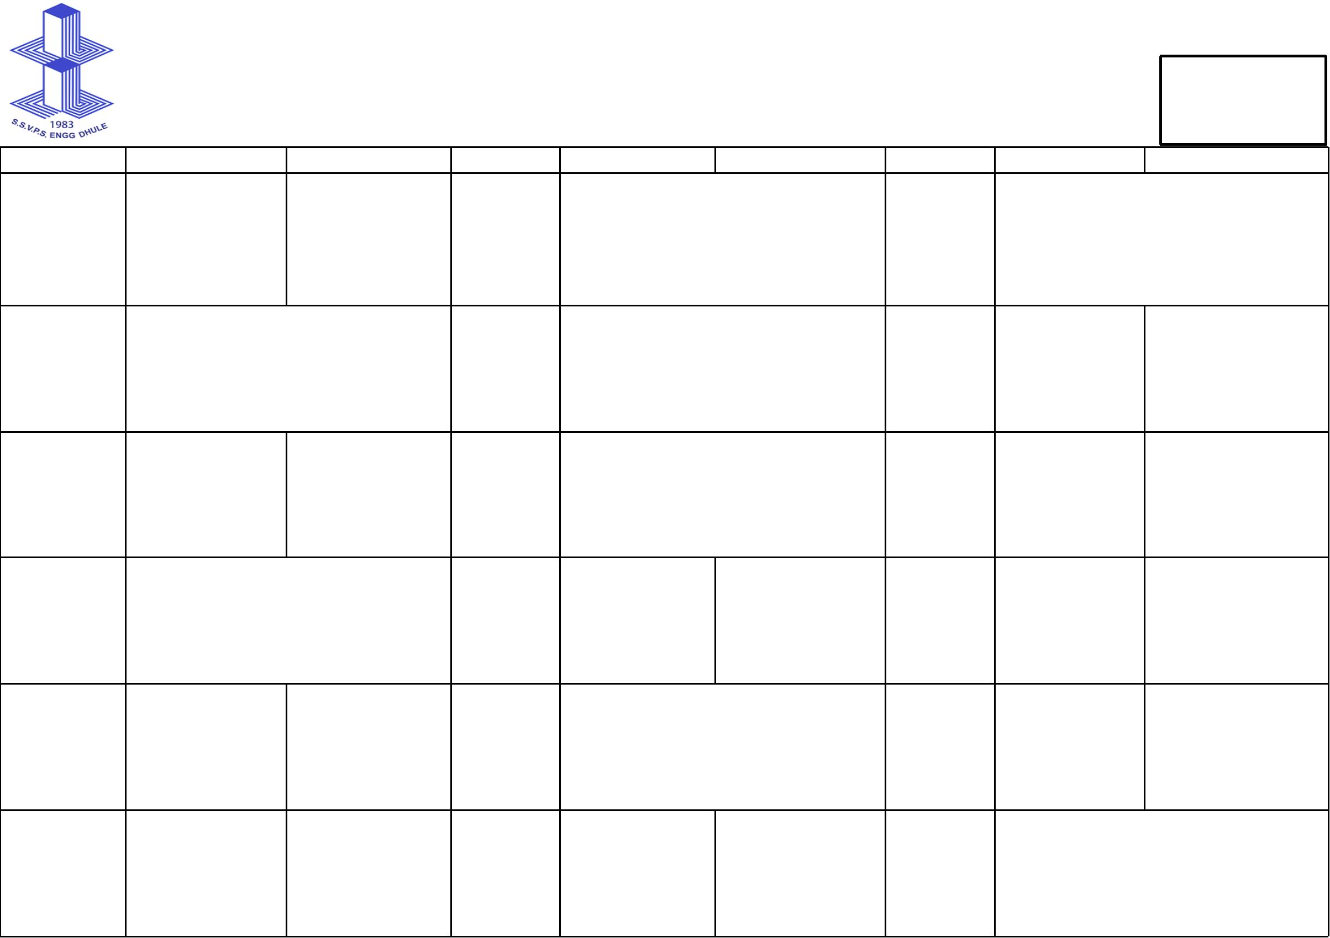

HEAD

E&TC

