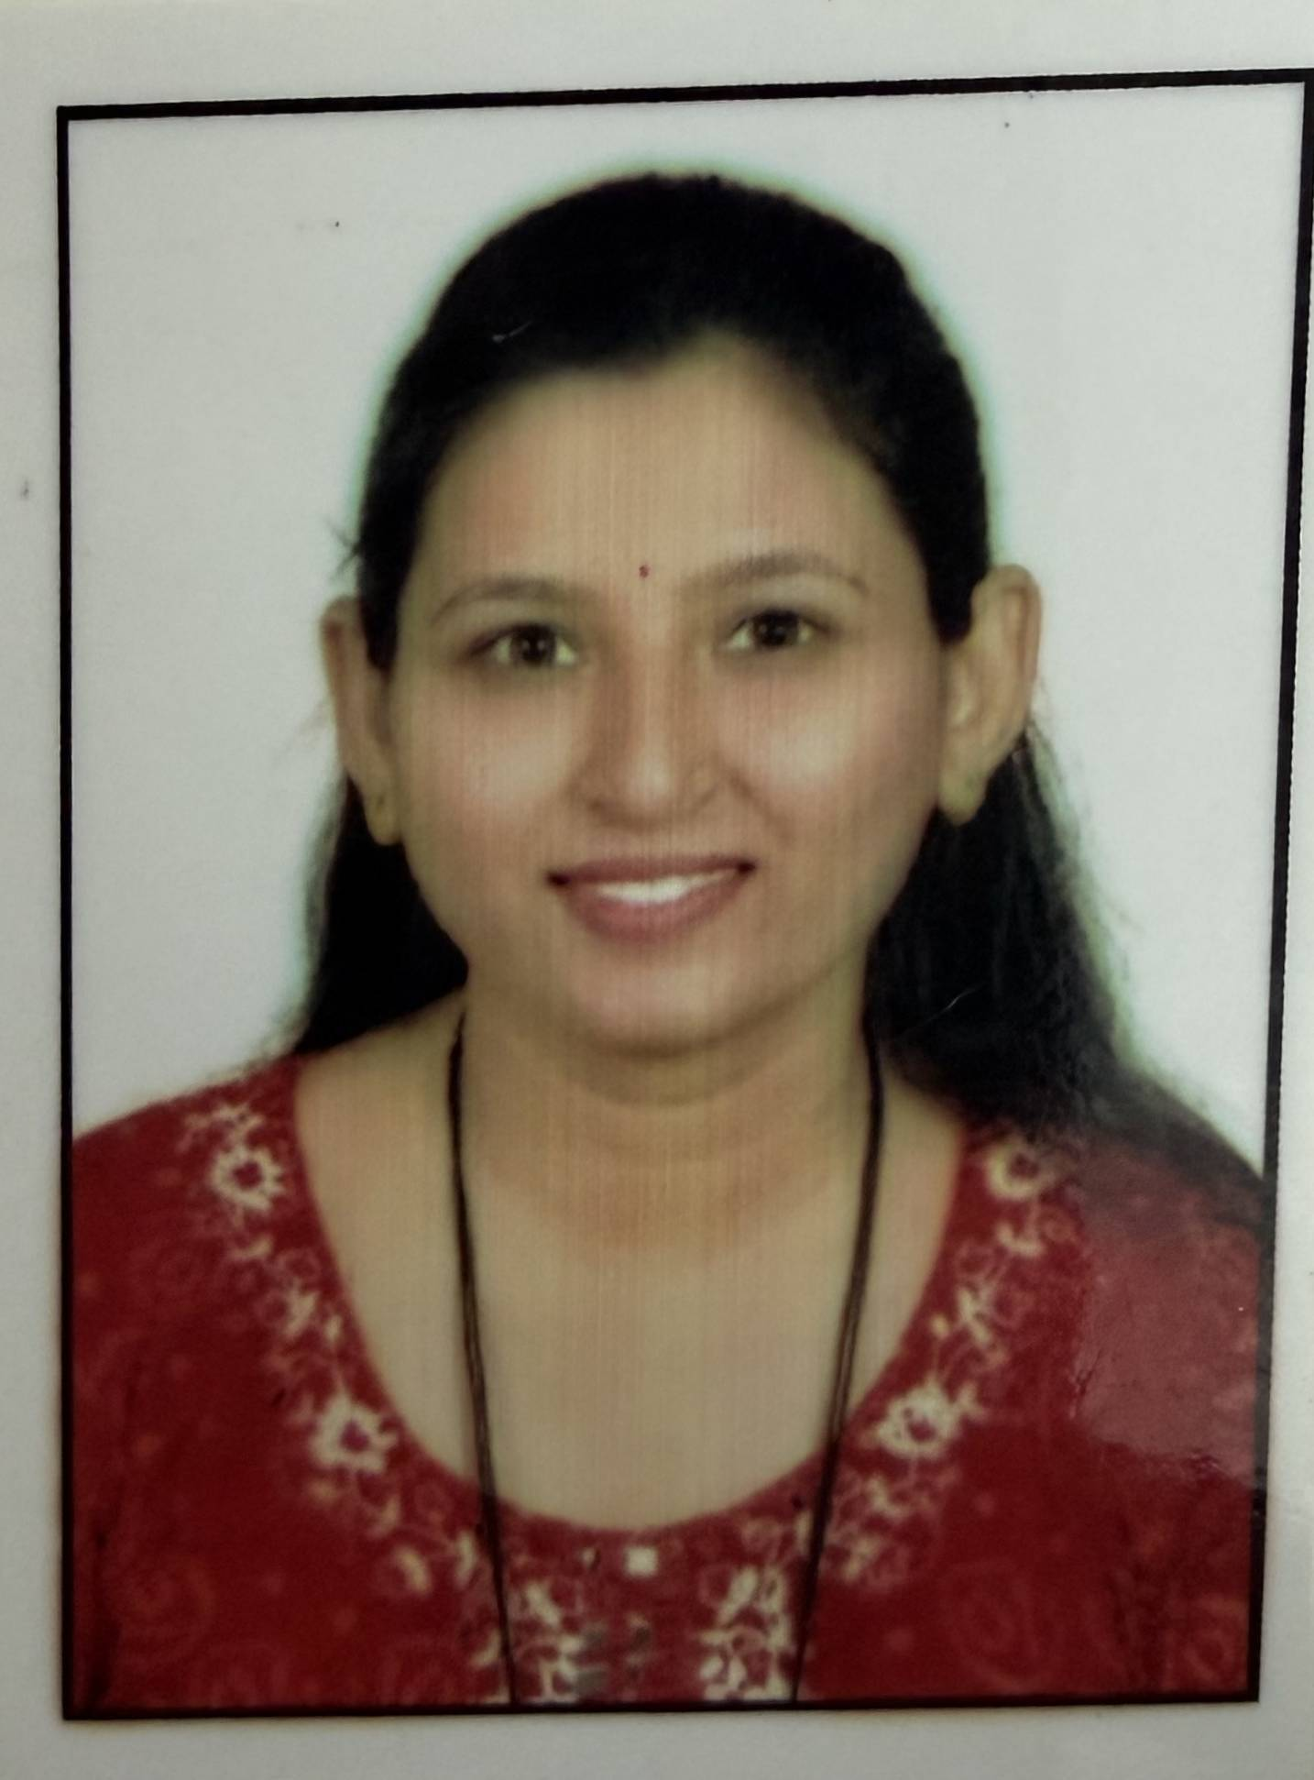
Vijaya G. Marathe

Mobile No.: 9011831885
Email ID: vijayamarathe29@gmail.com

Objective:

To work with an organization where I would get a chance to contribute my knowledge and to learn and grow with the organization.

Personal Information:

Name | Vijaya Gulab Marathe.
Father’s Name | Gulab Sahadu Marathe.
Husbunds Name | Prashant Arjun Marathe.
Date Of Birth | 29th Jan 1997
Address | Plot no. A/1 Aniruddha nagar near srpf petrol pump,sakri road,dhule 02
Gender | Female
Phone Number | +919011831885
Marital Status | Married
Nationality | Indian
Languages | English, Hindi, Marathi.

Computer Skills:

- Technical Application: AutoCAD.
- Microsoft Application: M.S. Word, M.S. Power point, M.S. Exel

Training:

- Institute Name : “Eka Training Institute Mumbai.”
- Duration : 15 Days
- Knowledge Achieved : Enhancement of soft skills.

Final Year Project (B. E):

- Project Title :”Concept of Hybrid Solar Windmill by Using Solar Concrete Segment”.
- Software : Google Sketch-Up
- Description : In this the combination of two Energy Resources is take place i.e.
Wind & Solar Energy. An Integrated Solar Concrete Segment has been
Designed, Prototyped & Validated. . An Integrated Solar Concrete
Segment Target Mid IR Wavelength, where Nano film Solar cells are
efficient and Wind turbine are used for converting wind energy into
Electricity.
Final Year Project (M. E):

- Project Title :”Behavioural study on black cotton soil using municipal waste ash”
- Description : This project studies the behavior of black cotton soil by partially replacing it with Municipal Waste Ash (MSA) at proportions of 5%, 10%, 15%, 20%, and 25% by weight. The objective is to evaluate the effect of MSA on the engineering properties of black cotton soil, including its strength, compaction, and bearing capacity. The study aims to identify the optimum percentage of MSA that improves soil performance while promoting the sustainable use of municipal waste as an eco-friendly soil stabilization material.

Professional Experience:

- Company name: IIC Technologies
  - Designation: GIS Engineer
  - Attainment: Map digitisation using AutoCad.
  - Experience: 1 Year 6 Months

- Institute name: Adarsh Polytechnic,Dhule
  - Designation: Lecturer
  - Attainment: Teaching undergraduate engineering students and conducting academic activities.
  - Designation: Incharge HOD
  - Attainment: Managing departmental administration, academic planning, faculty coordination, student mentoring, and accreditation-related activities.
  - Experience: 3 Years

Personal Trait:

Quick Learner, Hard & Smart Worker, Team Player, Problem solving ability, Co-operative and keen observer.

Extra-Curricular Activity:

- Paper Published in International Journal of Engineering Science & Computing (IJESC)
- Paper Published in 5th International Conference on Advanced Technologies for Societal Applications 2024.
- Paper Published in Akshara Multidisciplinary research journal 2026
- Participated in FDP, title is Essence of Indian constitution 2024
- Participated in FDP, title is Research Writing, Proposals, Funding & IPR 2025
- Participated in FDP, title is Geotechnical Engineering in the era of digital transformation: Systematic Integration of AI,IOT & Machine Learning 2026
- Participated in FDP, title is Green construction, Approach towards renewable energy and resource optimisation 2026

Hobbies:

- Learning Design Related Software
- Drawing
- Traveling

Educational Qualifications:
Sr.NO | EXAMINATION | YEAR | BOARD/UNIVERSITY | PERCENTAGE/  SGPA
01. | ME (Geotech) | 2023 | University of Pune | 7.56
02. | B.E.(Civil) | 2017-18 | University of Pune | 67.67
03. | HSC | 2013-14 | Nashik Board | 58.15
04. | SSC | 2012-13 | Nashik Board | 82.18

Declaration:

I hereby declare that the above written particulars are true to the best of my knowledge and belief.

Place: Dhule.
Date:

Applicant Sign

(Vijaya Gulab Marathe)

