Institute Mission:
To develop technocrats with awareness of Socio-economic needs for sustainable growth.

Institute Vision:
A Premier Institute as a dynamic entity contributing to human resource development.

Department of Mechanical Engineering

Department Vision:
“Facilitator for excellence in Mechanical Engineering.”

Department Mission:
- M1: To Develop Proficient Mechanical Engineers.
- M2: To Develop Mechanical Engineers with Social Awareness.
- M3: To Impart Knowledge, Skills and Values for Sustainable Development.

Department of Mechanical Engineering
Activity Report
- Submitted by: N.S.Deshmukh
- Date of Activity: 2022-2023, Project developed
Project Title | Economical Waste Segregation System for Multi-Storied College Building
Funding Agency | SSVPS’s Bapusaheb Shivajirao Deore College of Engineering, Dhule-424005
Organizers | Department of Mechanical Engineering, SSVPS’s Bapusaheb Shivajirao Deore College of Engineering, Dhule
Target Audience | Engineering students, faculty members, campus users and personnel involved in college waste management.
Brief Description of the activity | The project develops an economical mechanical waste segregation system for a multi-storied college building. Waste from floor-wise openings is conveyed through a main duct to a vibrating chamber. The system combines vibration, blower action, and permanent-magnet separation to segregate waste by its characteristics. The vibrating chamber transfers waste to subsequent chambers; the blower carries lightweight waste through a side duct to Chamber 3, while Chamber 2 collects heavier waste. The system is intended to reduce direct disposal or burning of mixed waste and support safer, more effective segregation within the campus.

Objectives | - To develop an economical mechanical waste segregation system for a multi-storied college building.  - To use vibration, blower action and magnetic separation for effective dry-waste segregation.  - To reduce mixed-waste disposal, landfill burden and the need for secondary segregation.  - To support safer waste handling and protection of the college campus and environment.

Achievements | 1. Economical waste segregation mechanism designed for a multi-storied college building.  2. Final assembled system installed at the college building.  3. The proposed arrangement provides separate collection paths for light-weight and heavier waste.
POs Mapped  (Add Mapped level 1,2,3)
  PO1 | PO2 | PO3 | PO4 | PO5 | PO6 | PO7 | PO8 | PO9 | PO10 | PO11 | PO12
  3 | 3 | 3 | 3 | 2 | 2 | 2 | 1 | 2 | 3 | 2 | 2
PSO’s Mapped  (Add Mapped levels 1, 2, 3)
  PSO1 | PSO2 | PSO 3
  3 | 2 | 3
SDG | SDG-9, SDG-11
Thematic Area | Sustainable waste management, mechanical system design, environmental protection and resource-efficient segregation.

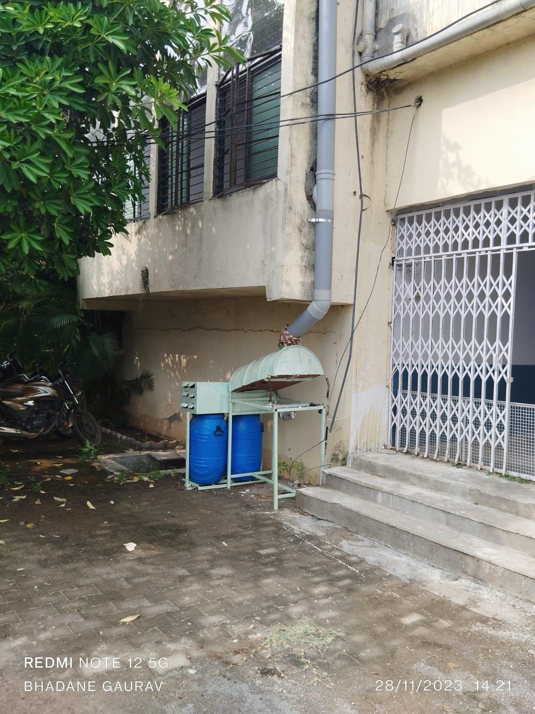
Figure 1: Waste segregation system installed in college building
Costing | The institute has given funding of Rs. 12000/- for fabrication of the project

Coordinator Head, Department of Mechanical Engineering

