Institute Mission:
To develop technocrats with awareness of Socio-economic needs for sustainable growth.

Institute Vision:
A Premier Institute as a dynamic entity contributing to human resource development.

Department of Mechanical Engineering

Department Vision:
“Facilitator for excellence in Mechanical Engineering.”

Department Mission:
- M1 : To Develop Proficient Mechanical Engineers.
- M2 : To Develop Mechanical Engineers with Social Awareness.
- M3 : To Impart Knowledge, Skills and Values for Sustainable Development.

Department of Mechanical Engineering
Activity Report
- Submitted by: Prof. D.C.Mahale
- Date of Activity: 23/09/2026
Project Title | Performance Analysis of Double-Pipe Heat Exchanger by Introducing a Flow Divider
Funding Agency
Organizers | ASM International ARTH
Target Audience | - Engineering students: To understand heat-transfer principles, flow distribution, and the practical performance of heat exchangers.  - Faculty and researchers: To study the effect of flow modification on heat-transfer rate, effectiveness, pressure drop, and thermal performance.  - Industries: Particularly chemical, pharmaceutical, food-processing, power-generation, refrigeration, and HVAC industries where heat exchangers are widely used.  - Design and process engineers: To evaluate the feasibility of using flow dividers for improving heat-exchanger performance and optimizing thermal systems.  - Technical institutions and laboratories: For educational demonstrations, experimentation, and further research in heat-transfer enhancement.  - Future researchers: To use the experimental results as a foundation for developing improved heat-exchanger designs and energy-efficient thermal systems.

Brief Description of the activity | The activity involves the design, fabrication, and experimental performance analysis of a double-pipe heat exchanger modified by introducing a flow divider in the annular space. The flow divider is incorporated to improve the flow distribution and increase the interaction between the fluid and heat-transfer surface. The performance of the modified heat exchanger is evaluated experimentally and compared with that of a conventional double-pipe heat exchanger.  Key performance parameters such as heat transfer rate, overall heat-transfer coefficient, effectiveness, temperature variation, fluid flow rate, and pressure drop are measured and analysed. The activity provides students with practical exposure to heat-transfer principles, fluid-flow behaviour, experimental techniques, instrumentation, data collection, and performance evaluation. The project also promotes innovation by investigating a simple, economical modification to enhance the thermal performance of a conventional heat exchanger.
Objectives | - To design and develop a modified double-pipe heat exchanger incorporating a flow divider in the annular space.  - To investigate the effect of the flow divider on fluid flow distribution and heat-transfer characteristics.  - To experimentally determine the heat-transfer rate and overall heat-transfer coefficient of the modified heat exchanger.  - To evaluate the effectiveness and thermal performance of the heat exchanger with and without the flow divider.  - To study the effect of operating parameters, such as fluid flow rate and temperature difference, on heat exchanger performance.  - To analyse pressure drop and associated pumping requirements due to the introduction of the flow divider.  - To compare the performance of the conventional and modified double-pipe heat exchanger.

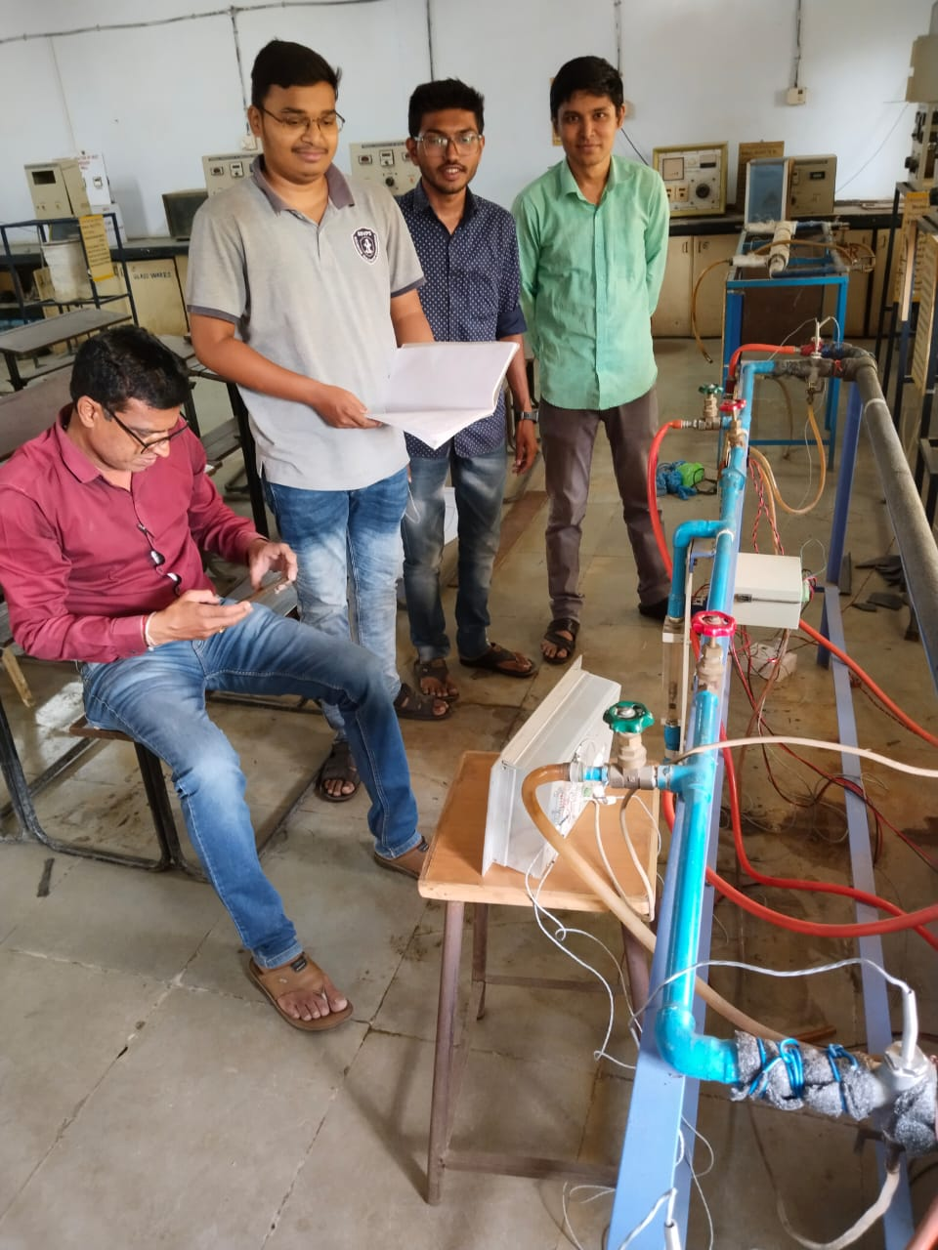


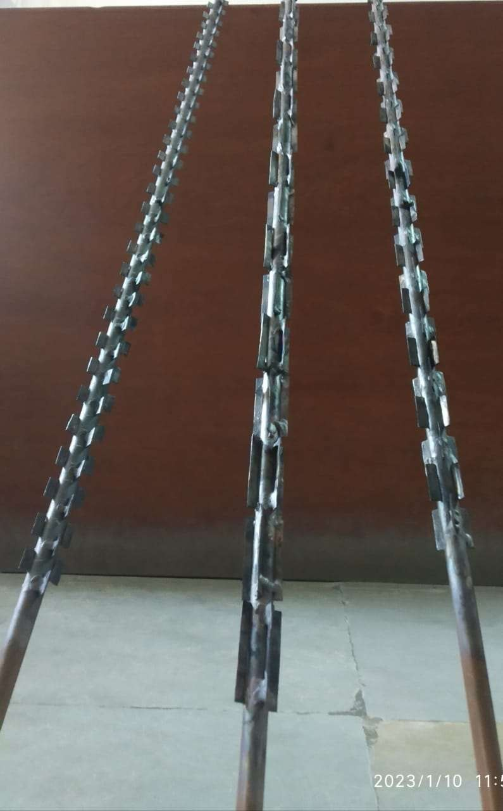
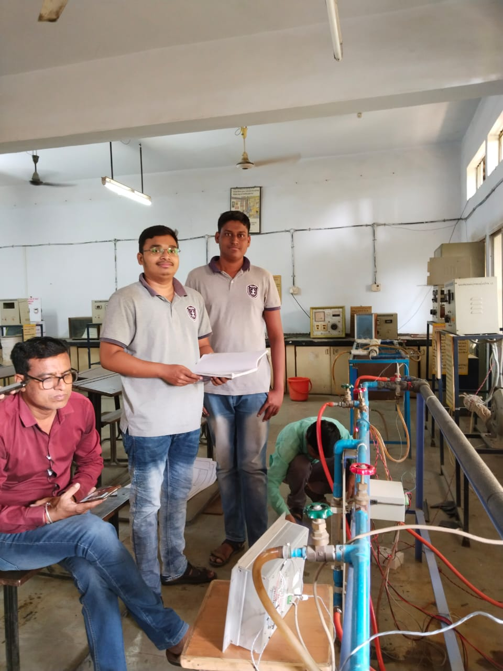

Achievements | - Successfully designed and developed a modified double-pipe heat exchanger by introducing a flow divider in the annular space.  - Demonstrated the practical feasibility of using a flow divider to improve fluid flow distribution and heat-transfer performance.  - Successfully conducted experimental testing and data collection for the conventional and modified heat exchanger configurations.  - Evaluated important performance parameters such as heat-transfer rate, overall heat-transfer coefficient, effectiveness, temperature variation, and pressure drop.  - Established a comparative performance analysis between the conventional heat exchanger and the heat exchanger with a flow divider.  - Provided students with hands-on experience in heat transfer, fluid mechanics, instrumentation, fabrication, experimentation, and data analysis.  - Developed an economical and relatively simple heat-transfer enhancement approach that can be further investigated for practical and industrial applications.  - Strengthened students' problem-solving, teamwork, technical documentation, experimental investigation, and innovative thinking skills, supporting NBA graduate attributes and outcome-based education.
POs Mapped  (Add Mapped level 1,2,3)
  PO1 | PO2 | PO3 | PO4 | PO5 | PO6 | PO7 | PO8 | PO9 | PO10 | PO11 | PO12
  3 | 3 | 3 | 3 | 0 | 3 | 3 | 2 | 2 | 0 | 2 | 2
PSO’s Mapped  (Add Mapped levels 1, 2, 3)
  PSO1 | PSO2 | PSO3
  3 | 2 | 2
SDG | - SDG 7  - SDG 9  - SDG 12.  - SDG 13
Thematic Area | Energy Efficiency, Heat Transfer Enhancement and Sustainable Thermal Engineering – focusing on innovative modification of double-pipe heat exchangers for improved heat-transfer performance and efficient utilization of energy.

Coordinator Head, Department of Mechanical Engineering

