Institute Mission:
To develop technocrats with awareness of Socio-economic needs for sustainable growth.

Institute Vision:
A Premier Institute as a dynamic entity contributing to human resource development.

Department of Mechanical Engineering

Department Vision:
“Facilitator for excellence in Mechanical Engineering.”

Department Mission:
- M1 : To Develop Proficient Mechanical Engineers.
- M2 : To Develop Mechanical Engineers with Social Awareness.
- M3 : To Impart Knowledge, Skills and Values for Sustainable Development.

Department of Mechanical Engineering
Activity Report
- Submitted by: Prof. D.C.Mahale
- Date of Activity: 23/09/2026
Project Title | Design, development and installation of 6 kW Gorlow turbine at right canal of Akkalpada dam
Funding Agency | DPC Dhule
Organizers | ASM International
Target Audience | - Engineering and technology students and faculty members interested in renewable energy and micro-hydropower systems.  - Farmers and local communities dependent on canal water and irrigation facilities.  - Government departments, local authorities, and water-resource management agencies.  - Students, researchers, and professionals working in renewable energy, electrical engineering, mechanical engineering, and sustainable development.  - The general public, with the objective of creating awareness about clean energy generation and efficient utilization of available water resources.

Brief Description of the activity | The activity aims to utilize the available flow of canal water for small-scale renewable energy generation without significantly affecting its primary irrigation purpose. The project involves the study of site conditions, hydraulic and electrical requirements, turbine design and development, installation, testing, and performance evaluation. The activity provides practical exposure to students and promotes awareness of renewable energy, micro-hydropower generation, sustainable engineering practices, and efficient utilization of water resources.
Objectives | - To design and develop a 6 kW Gorlow turbine suitable for installation at the right canal of Akkalpada Dam.  - To utilize the available canal water flow for renewable electricity generation without affecting its primary irrigation purpose.  - To demonstrate the feasibility of micro-hydropower generation using existing water infrastructure.  - To provide students with practical exposure to turbine design, fabrication, installation, testing, and performance evaluation.  - To promote awareness and application of clean, sustainable, and low-carbon energy technologies.  - To encourage innovation and problem-solving in the field of renewable energy and sustainable engineering.  - To contribute to the efficient and sustainable utilization of available water resources for community benefit.
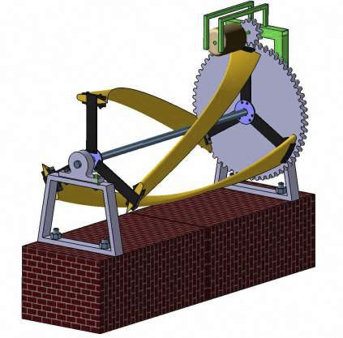

CATIA MODEL

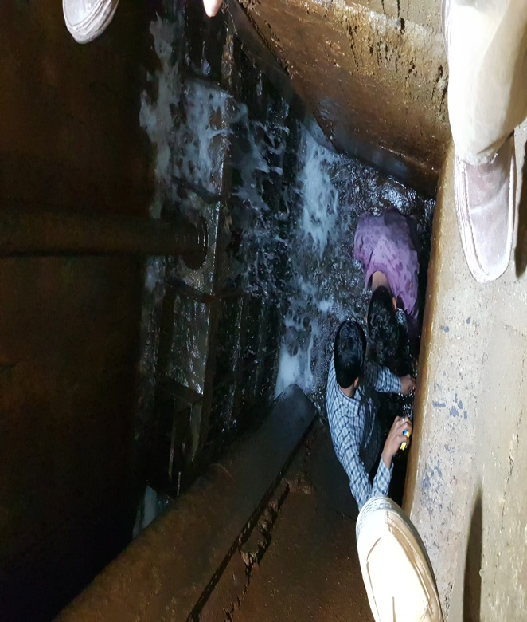
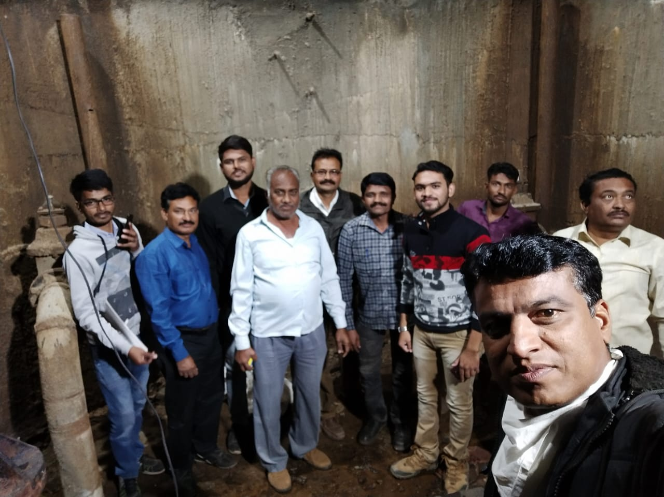

Visited at Akkalpada Dam to take measurements of the canal with Hon. Prof. Dr S. D. Suryawanshi and Prof. D. C. Mahale Sir with irrigation department staff

Achievements | - Successfully designed and developed a 6 kW Gorlow turbine system suitable for installation at the right canal of Akkalpada Dam.  - Identified the potential of canal water flow for small-scale renewable energy generation.  - Developed practical understanding of hydraulic turbine design, fabrication, installation, and electrical power generation.  - Demonstrated the feasibility of utilizing existing canal infrastructure for clean and sustainable energy production.  - Provided students with hands-on exposure to renewable energy technology and real-world engineering applications.  - Promoted awareness among students and the local community regarding micro-hydropower generation and sustainable utilization of water resources.  - Contributed to the objectives of community engagement, experiential learning, and sustainable development under the NBA activity framework  - This project will be developed for application in high attitude remote army Camps like Tawang Chu run of river.
POs Mapped  (Add Mapped level 1,2,3)
  PO1 | PO2 | PO3 | PO4 | PO5 | PO6 | PO7 | PO8 | PO9 | PO10 | PO11 | PO12
  3 | 3 | 3 | 3 | 0 | 3 | 3 | 2 | 2 | 0 | 2 | 2
PSO’s Mapped  (Add Mapped levels 1, 2, 3)
  PSO1 | PSO2 | PSO3
  3 | 2 | 2
SDG | - SDG 7  - SDG 9  - SDG 6  - SDG 12.  - SDG 13  - SDG 4
Thematic Area | The activity primarily focuses on developing and applying renewable energy technology through the design, development, and installation of a 6 kW Gorlow turbine at the right canal of Akkalpada Dam. It promotes clean energy generation, efficient utilisation of water resources, sustainable engineering practices, innovation in micro-hydropower technology, and practical experiential learning.

Coordinator Head, Department of Mechanical Engineering

