Institute Mission:
To develop technocrats with awareness of Socio-economic needs for sustainable growth.

Institute Vision:
A Premier Institute as a dynamic entity contributing to human resource development.

Department of Mechanical Engineering

Department Vision:
“Facilitator for excellence in Mechanical Engineering.”

Department Mission:
- M1: To Develop Proficient Mechanical Engineers.
- M2: To Develop Mechanical Engineers with Social Awareness.
- M3: To Impart Knowledge, Skills and Values for Sustainable Development.

Department of Mechanical Engineering
Activity Report
- Submitted by: Prof. Dr Sanjeev Damodhar Suryawanshi /Prof N.S.Deshmukh
- Date of Activity: 2024 -2025
Project Title | Performance Analysis of Waste-to-Best Solar Water Heater
Funding Agency | Institute-funded (self-financed student project) — SSVPS's Bapusaheb Shivajirao Deore College of Engineering, Dhule
Organizers | COEP Technological University in collaboration with BHAU's Innovation and Entrepreneurship Cell
Target Audience | Rural and economically weaker households, small-scale domestic and light-industrial water-heating users, farmers and self-help groups, plastic-waste recyclers/entrepreneurs, and students and researchers working in renewable-energy and sustainable-design domains.

Brief Description of the activity | This activity documents the design, fabrication, and performance evaluation of a low-cost, indigenous solar water heater that converts waste PET (polyethene terephthalate) bottles into the glazing/collector cover of a thermosyphon-based solar collector, replacing the imported, expensive glass-tube glazing used in conventional Evacuated Tube Collectors (ETC). Waste bottles are cut and fitted with an interference fit over PVC absorber pipes and sealed with clear silicone sealant, forming an airtight, sunlight-transmitting glazing that lets solar radiation heat the absorber pipe while still allowing visibility of internal water flow. The collector works on the thermosyphon principle: water heated inside the absorber rises by natural convection into an elevated storage tank while cooler, denser water flows back into the collector, eliminating the need for a circulation pump. Three configurations (32 mm, an eccentric 32 mm-in-40 mm, and an eccentric 40 mm-in-50 mm pipe arrangement) were fabricated and tested to study how reducing the 'dead volume' inside the absorber affects heating rate and peak temperature, with the best configuration reaching about 65–66°C. The technology addresses two problems simultaneously: (i) the high cost and import dependence of ETC-based solar water heaters, which puts solar water heating out of reach of financially weaker households, and (ii) the growing burden of non-biodegradable PET-bottle waste, which takes hundreds of years to decompose and is only partially recycled in India. By diverting waste bottles from landfills into a functional renewable-energy device, the project delivers an eco-friendly, indigenous, low-production-cost alternative to ETC/flat-plate collectors with comparable thermal performance, supporting both clean-energy adoption and circular-economy/plastic-waste-management goals at the household and community level.
Objectives | 1. To design and fabricate a low-cost, indigenous solar water heater collector using waste PET bottles as the glazing material in place of conventional glass/ETC glazing.  2. To reduce plastic pollution by repurposing non-biodegradable waste bottles into a functional renewable-energy component, supporting sustainable plastic-waste management.  3. To study and optimise the thermosyphon performance of different absorber-pipe configurations by minimising the collector's dead volume.  4. To achieve solar water heating performance comparable to conventional flat-plate and Evacuated Tube Collectors (ETC) at a significantly reduced production cost.  5. To promote affordable, decentralised solar water-heating solutions for rural and economically weaker communities, in line with clean-energy and circular-economy goals.

Achievements | 1) Abstract accepted for Poster Presentation at the Solar World Congress (SWC) 2023, New Delhi, organised by the International Solar Energy Society (ISES) — Abstract ID SWC23_ABS_G5480.  2) Research paper published at the National Conference on Energy and Environment for Sustainable Development, Avsari.  3) Selected in the American Society for Materials (ASM) International Innovation Project Competition, Mumbai.  4) Winner, Inter-College Avishkar Research Competition, Dhule.  5) Selected in the Maharashtra Startup Yatra Project Competition, Dhule.  6) Winner, Research Paper Competition, SSVPS's B.S.D. College of Engineering, Dhule.  7) Indian Patent filed: "Solar Collector Using Plastic Glazing", Patent No. 201821005958 (dated 16/02/2018).  8) Showcased as a student innovation project at Pune Startup Fest 2025 (PSF).
POs Mapped  (Add Mapped level 1,2,3)
  PO1 | PO2 | PO3 | PO4 | PO5 | PO6 | PO7 | PO8 | PO9 | PO10 | PO11 | PO12
  3 | 3 | 3 | 3 | 2 | 2 | 2 | 2 | 1 | 2 | 2 | 1
PSO’s Mapped  (Add Mapped levels 1, 2, 3)
  PSO1 | PSO2 | PSO3
  3 | 1 | 2
SDG | SDG 7 — Affordable and Clean Energy; SDG 12 — Responsible Consumption and Production (plastic-waste reuse)
Thematic Area | Renewable energy technologies; Solar thermal systems; Plastic-waste management and recycling

Design of Collector:
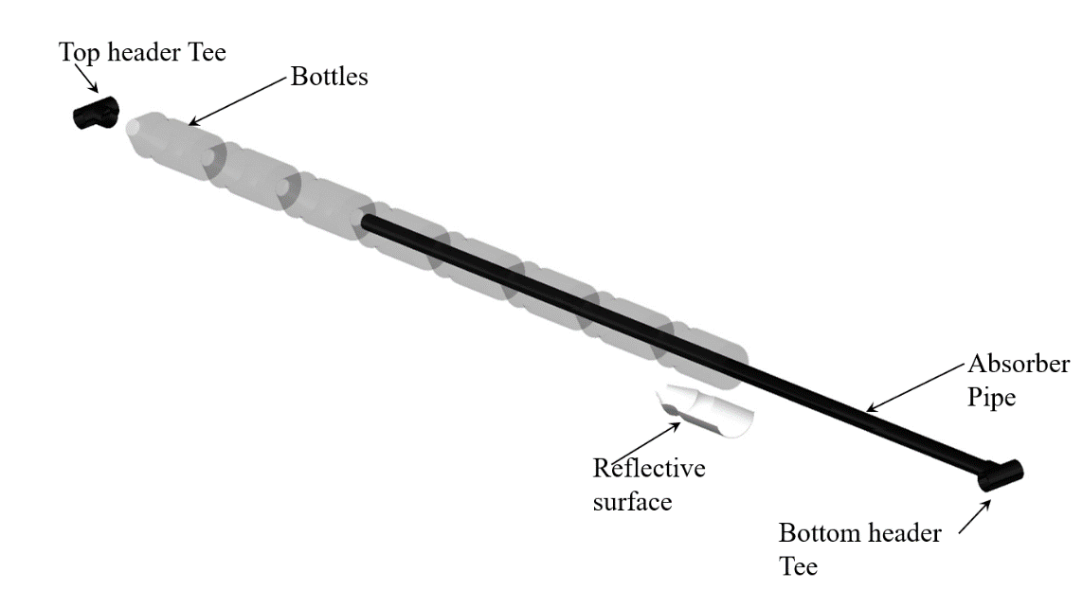

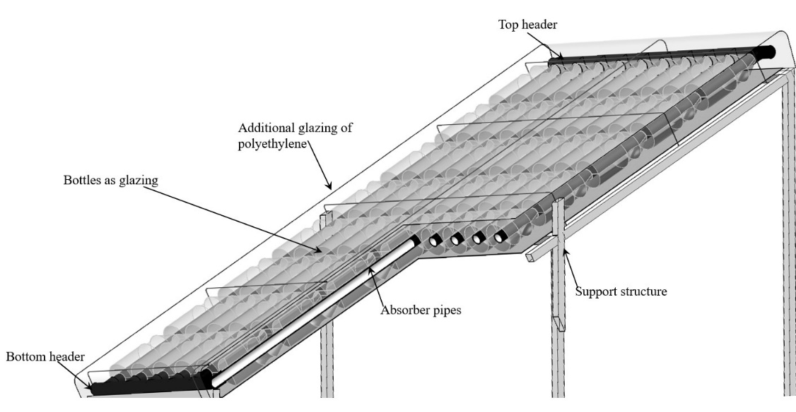

Installation of Collector:
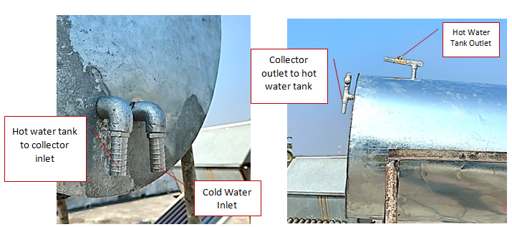
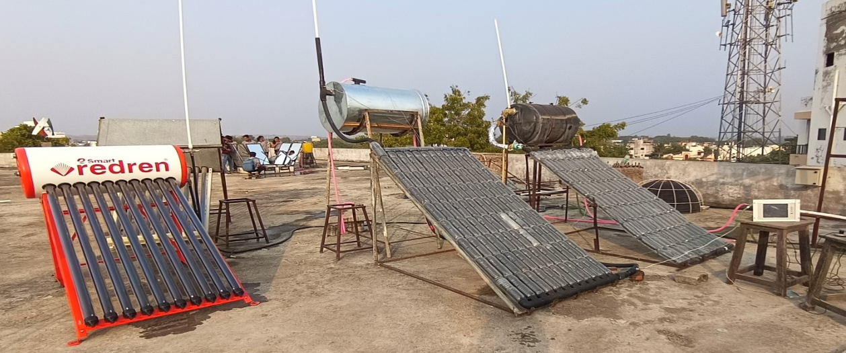

Coordinator Head, Department of Mechanical Engineering

