Institute Mission:
To develop technocrats with awareness of Socio-economic needs for sustainable growth.

Institute Vision:
A Premier Institute as a dynamic entity contributing to human resource development.

Department of Mechanical Engineering

Department Vision:
“Facilitator for excellence in Mechanical Engineering.”

Department Mission:
- M1: To Develop Proficient Mechanical Engineers.
- M2: To Develop Mechanical Engineers with Social Awareness.
- M3: To Impart Knowledge, Skills and Values for Sustainable Development.

Department of Mechanical Engineering
Activity Report
- Submitted by: Prof. D. D. Bagale (Project Guide) / Prof. Dr Sanjeev D. Suryawanshi (Co-Guide & Head, Department of Mechanical Engineering)
- Student Team: Ruchita Ganesh Dhangar, Prerana Champalal Rathod, Bhavesh Parasharam Deore
- Date of Activity: 2022-2023, Project developed
Project Title | Fabrication and Testing of Solar Cooker with Heat Storage
Funding Agency | Institute-funded (self-financed student project) — SSVPS's Bapusaheb Shivajirao Deore College of Engineering, Dhule
Organizers | Department of Mechanical Engineering, SSVPS's Bapusaheb Shivajirao Deore College of Engineering, Dhule
Target Audience | Rural and semi-urban households, community kitchens, hostels and ashrams, farmers and agro-based communities, and other stakeholders seeking affordable, renewable-energy-based cooking solutions.

Brief Description of the activity | This activity documents the design, fabrication and performance evaluation of a low-cost, high-insulation, box-type solar cooker integrated with a sensible-heat-storage system. The cooker body is constructed from Autoclaved Aerated Concrete (AAC) blocks, chosen for their light weight, low thermal conductivity and excellent insulating properties, and houses four independently accessible, side-loading cooking chambers separated by reflective partition walls. Six booster mirrors (4 mm thick glass, two per side) concentrate additional solar radiation onto a 1 m² absorber area without requiring frequent sun-tracking. The key innovation is its heat-recovery architecture: interconnected copper-tube “pockets” embedded in the side walls and a copper coil in the base capture heat that would otherwise be lost to the environment and use it to progressively heat water by natural thermosyphon action. This preheated water travels through the pocket network into an insulated stainless-steel storage tank (insulated with Rockwool), from which it can be drawn via an outlet tap for cooking or other domestic use, including after sunset. Field testing recorded chamber temperatures of up to 150–173°C and demonstrated a cooking capacity of about 2.75 kg of rice, with 7–8 litres of hot water available for reuse per cycle. By recovering waste heat instead of dissipating it, the design overcomes two persistent limitations of conventional box-type and concentrating solar cookers restricted cooking hours due to cloud cover or the need for periodic sun-tracking and unused heat loss through the side walls and base, making it well suited for community-scale applications such as hostels, ashrams and rural kitchens.
Objectives | 1. To design and fabricate a low-cost, high-insulation box-type solar cooker using AAC blocks that minimises heat loss through the side walls and base.  2. To develop an integrated sensible-heat-storage system, using interconnected copper-tube pockets and an insulated water tank that captures otherwise-wasted heat and makes preheated water available for cooking and domestic use, including after sunset.  3. To reduce cooking time and dependence on conventional fuels by increasing effective solar-energy utilisation through booster mirrors and a multi-chamber, side-loading design that eliminates the need for frequent sun-tracking.  4. To evaluate the thermal performance of the cooker under loaded and unloaded conditions and validates its suitability for community-scale cooking applications such as hostels and ashrams.  5. To promote affordable, indigenous, renewable-energy-based cooking solutions that reduce reliance on biomass and fossil fuels for domestic and institutional cooking.
Achievements | 1. Indian Patent filed (application in process): “Brick Box-Type Solar Cooker” (basic version) — Application No. 201621012701.  2. Indian Patent filed (application in process): “Brick Box-Type Solar Cooker with Heat Storage” — Application No. 201821041516.  3. B.Tech Project Report, “Fabrication and Testing of Solar Cooker with Heat Storage,” Department of Mechanical Engineering, SSVPS's B.S. Deore College of Engineering, Dhule (AY 2022–23), guided by Prof. D. D. Bagale.  4. Demonstrated performance: cooking capacity of 2.75 kg rice, chamber temperatures up to 150–173°C, and 7–8 litres of reusable preheated water per cycle.

POs Mapped  (Add Mapped level 1,2,3)
  PO1 | PO2 | PO3 | PO4 | PO5 | PO6 | PO7 | PO8 | PO9 | PO10 | PO11 | PO12
  3 | 3 | 3 | 3 | 2 | 2 | 2 | 2 | 1 | 2 | 2 | 1
PSO’s Mapped  (Add Mapped levels 1, 2, 3)
  PSO1 | PSO2 | PSO3
  3 | 1 | 2
SDG | SDG 7 — Affordable and Clean Energy; SDG 12 — Responsible Consumption and Production (reduced dependence on biomass/fuel-wood)
Thematic Area | Renewable energy technologies; Solar thermal systems; Sustainable/clean-cooking solutions

Graphical representation of Solar Box Type Cooker

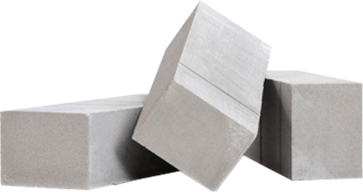
Autoclaved aerated concrete (AAC) blocks

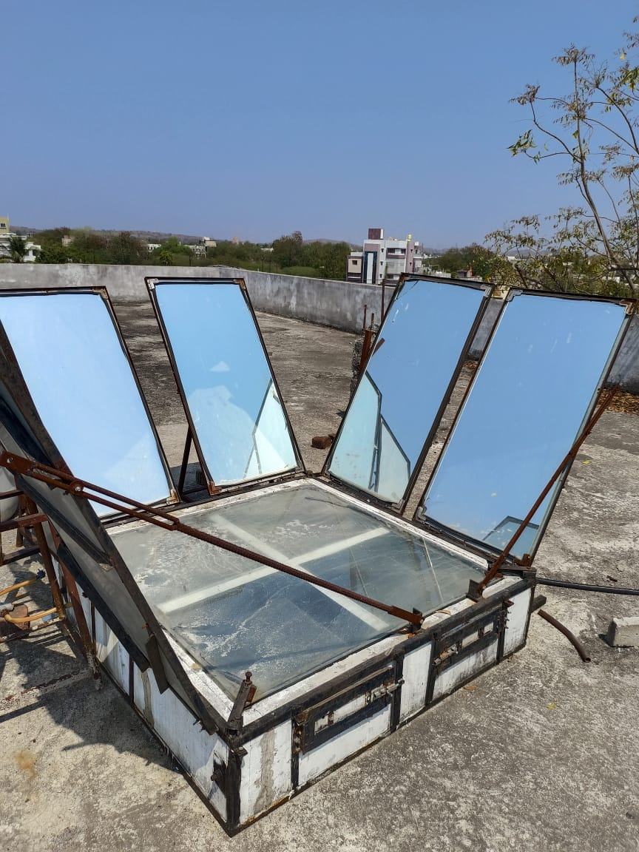
Reflective Mirrors
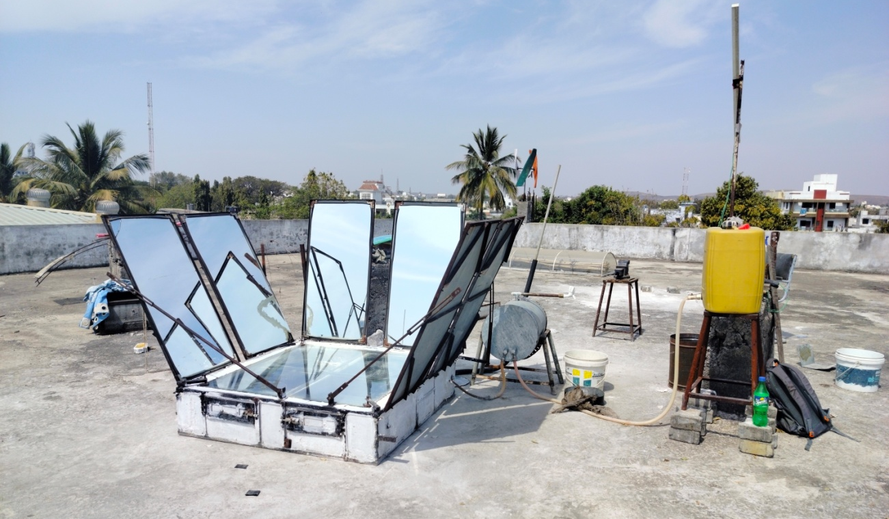
Setup of Solar Cooker with Heat Storage
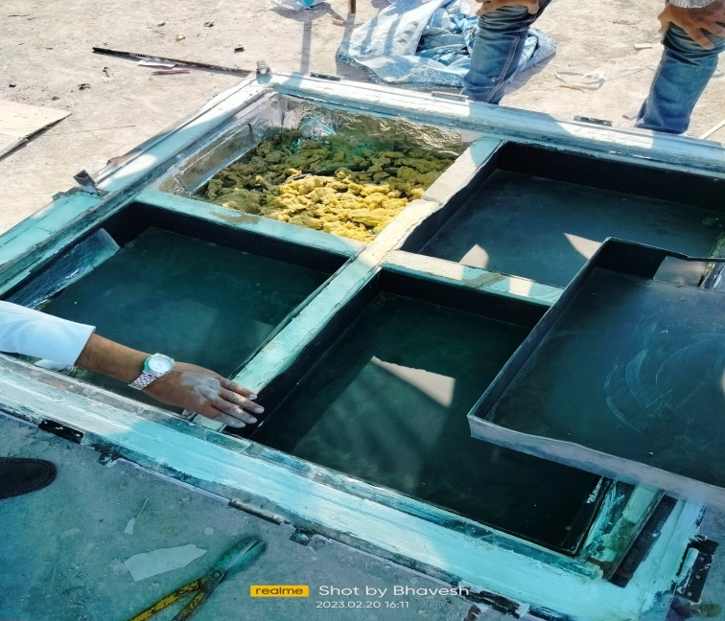
Installation of Chamber

Coordinator Head, Department of Mechanical Engineering

