Department of Mechanical Engineering
Activity Report
- Submitted by: Prof. I. N. Wankhede, Dr S. D. Suryawanshi
- Date of Submission: 7th March 2026
- Organised by: SSVPS B. S. Deore College of Engineering, Dhule.
Activity Type | Project Development
Activity Title | Design and Field Validation of Foldable Solar Heated Tent for Extreme Conditions
Dates(s) of Activity | 19th Feb 2026 To 6th March 2026
Duration | 16 Days
Organizers | - SSVPS B. S. Deore College of Engineering, Dhule.  - Department of Mechanical Engineering  - Indian Army
Target Audience | Mechanical engineering students, faculty members, project development teams, and Institution’s Innovation Council (IIC) members involved in innovation and prototype testing.
Brief Description of the activity | The Department of Mechanical Engineering conducted project development and field trials of the indigenously developed “Foldable Cum Portable Solar Heated Tent as a Movable Shelter” at Tawang and Sungetsar Lake, Arunachal Pradesh. The trials tested the prototype in extreme cold conditions to evaluate thermal efficiency, structural stability, portability, and ease of deployment. This activity provided students and faculty hands-on experience in developing a practical, energy-efficient, and quickly deployable shelter solution for harsh environments.
Objectives | - Develop and test a portable solar-heated tent prototype under real field conditions.  - Evaluate the performance, durability, and thermal efficiency of the tent in extreme cold environments.  - Provide hands-on practical experience in design, prototyping, and field testing for students.  - Enhance problem-solving and innovation skills through real-world project implementation.  - Assess structural stability, ease of deployment, and portability of the shelter system.  - Promote sustainable engineering solutions for mobile and emergency shelters.
Pos Mapped  (Add Mapped level 1,2,3)
  PO1 | PO2 | PO3 | PO4 | PO5 | PO6 | PO7 | PO8 | PO9 | PO10 | PO11 | PO12
  2 | 2 | 1 |  | 1 |  | 1 |  | 2 | 1 | 1

PSO’s Mapped  (Add Mapped level 1,2,3)
  PSO1 | PSO2 | PSO3
  2 | 1
Resource Person(s)
(If applicable)
Outcomes and Learning Points | - Gained practical experience in prototype design and testing.  - Learned about thermal efficiency and structural stability of the tent.  - Improved teamwork and coordination during field trials.  - Applied engineering knowledge to solve real-world problems.  - Developed problem-solving and decision-making skills.  - Learned to record and analyze field trial data.  - Encouraged further innovation in sustainable shelter solutions.
Photos | 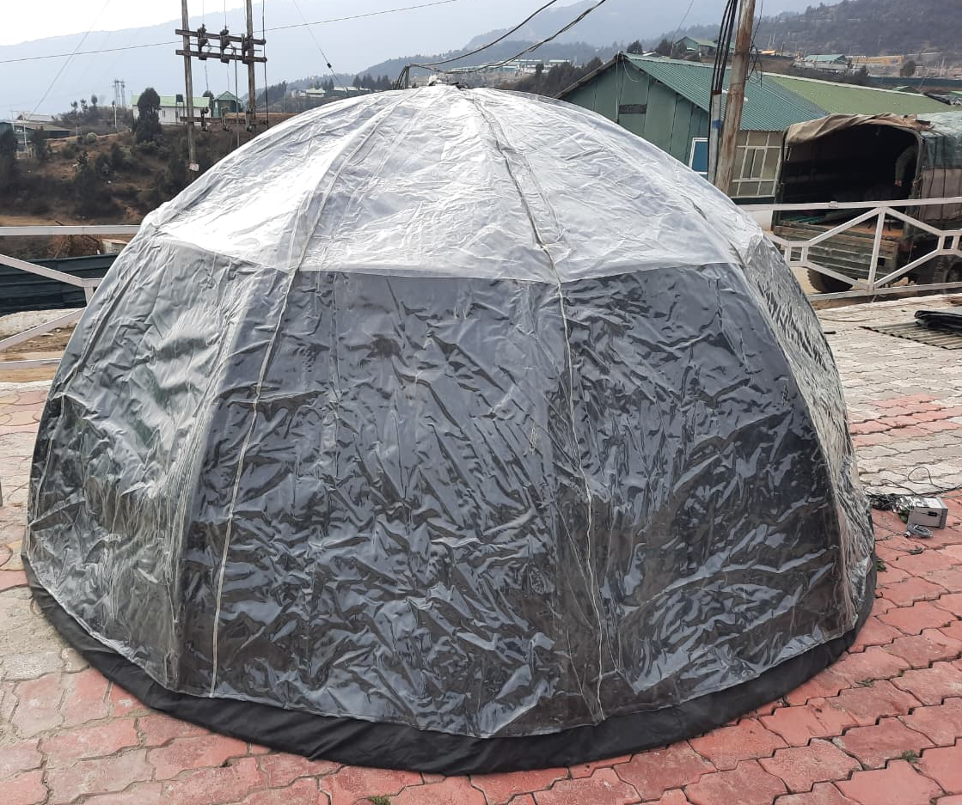  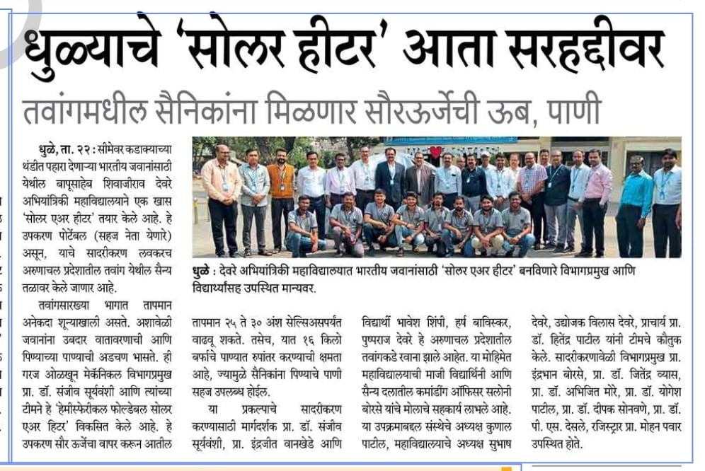  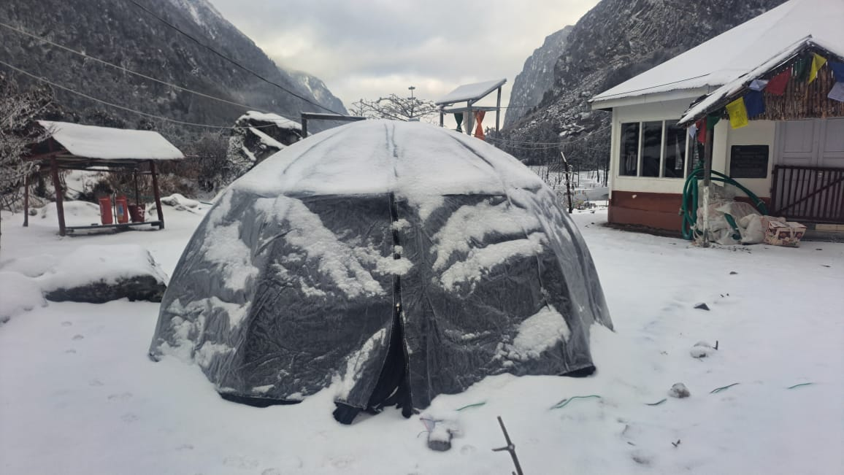
 | 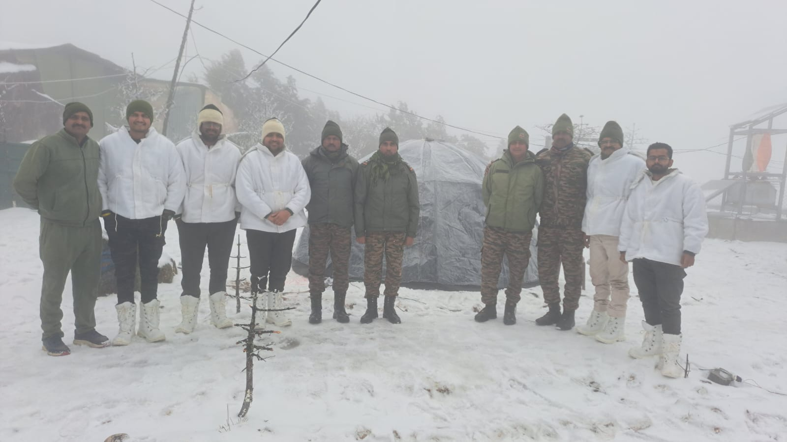

Co-ordinator HOD.

