S.S.V.P.S’s Bapusaheb Shivajirao Deore College of Engineering, Dhule

INDUSTRIAL VISIT REPORT

DEPARTMENT OF ELECTRONICS ENGINEERING

INDUSTRIAL VISIT REPORT

INDUSTRIAL VISIT BY SECOND & THIRD YEAR STUDENTS OF B.Tech. in Electronics Engg./Electronics & Comp. Engg.
TO

KRUGER VENTILATION INDUSTRIES (INDIA) PVT. LTD.

CONTENTS

JOURNEY DETAILS

COMPANY PROFILE

OBSERVATIONS AND LEARNING

CONCLUSION

JOURNEY DETAILS
The Department of Electronics Engineering, S.S.V.P.S’s B. S. Deore College Of Engineering,Dhule had organized an industrial visit on 16/11/2025 to Kruger Ventilation Industries(India) PVT. LTD., Plant 1, Kruger Centre, Kalamgaon, Mumbai Nashik Highway, Shahapur, Thane, Maharashtra 421601, India which is a leading Ventilators suppliers for railways and metros the Mechanical and Electronics System & Design Manufacturing Services.
  - The industrial visit was organized for the second & third year students of B.Tech Electronics Engg./Electronics & Computer Engg.
  - The intention of visit was to give students a practical exposure to the functional areas of management in a production unit.
  - Two teachers accompanied the students. There were 61 students in the group.
  - All the arrangements were done by the Industrial tour committee of the department led by Prof. Dipmala M.Patil , Assistant Professor.
Detailed tour from 13 November 2025 to 16 November 2025.
On 13 Nov 2025 all students with two teaching faculty departed from college campus at 10:30 pm.
- Day 1: Arrival at Malvan on 14 Nov 2025 at 7:30 pm

- Sightseeing
- Sindhudurg Fort
- Rajkot Fort
- Chiwala Beach & Rock Garden
- Golden Ganesh Temple
- Malvan Fish Auction (Dinner & Overnight Stay)

- Day 2: Beaches & Temples
- Tarkarli Beach, Devbag Beach
- Agnewadi temple ,Ozer crave & Golden Rock (Dinner and overnight stay)
- Day 3
- Sightseeing
- Devgad Windmill Garden & Coastal Road
- Kunkeshwar Mandir & Beach
- Arevare beach

- Ganpatipule temple & beach

Way to Shahapur for industrial visit

COMPANY PROFILE

Established in Singapore since 1985, Kruger Ventilation Group is a full subsidiary company of Soler & Palau Ventilation Group, headquarter in Spain. Kruger is a leading supplier of energy efficient ventilation solutions for residential and commercial buildings, industrial applications and infrastructures. Currently, Kruger established 18 business units in Asia Pacific Region.
With our wealth of knowledge and know-how, Kruger believes in creating value for customers simply by understanding their needs and delivering expectations. On this website, we are proud to present to you our products that are of high quality, competitive in pricing and of international standards. However, we will not stop here; we will be constantly seeking ways to continue providing our customers with good quality service and products. We recognise our customers’ importance and their requirements as one of our key strategy to achieve better customer service. To propel this ambition further, Kruger Research team has been launched to engineer advanced fan systems to expand its range of ventilation systems to provide a wider selection. Our team of engineers is determined to research and develop the most effective solution to meet our customers’ ventilation needs.
In 2016, Ferrari Ventilator Industrial S.p.A, a member of the Solar and Palau Ventilation group established Ferrari Asia Ventilation Co., Ltd. (FAV) in Thailand. With this new manufacturing base in Asia, we strive to serve our customer with better quality, service and delivery. Through the extensive presence of 18 units of Kruger Ventilation Group across Asia, we can deliver better value to our customer in Asia.

Ground report:-
According the route and time plan one busses was departed and reached the smart gate of Kruger Ventilation Industries (India) PVT. LTD. After checking,we went in other bus for terminal point of port.

Kruger Ventilation Industries (India) Private Limited's turnover is not publicly available, but financial reports for a related but now-amalgamated entity, Kruger Ventilation Industries (North India) Private Limited, show a revenue of ₹27.5 crore for the financial year ending March 31, 2021. For the main entity, Kruger Ventilation Industries (India) Pvt. Ltd., a more recent report shows an operating income of ₹264.35 crore for the financial year ending March 31, 2023. The company has been in operation for over two decades and is a leader in the Indian HVAC industry.
Kruger Ventilation Industries (India) Private Limited, located in Shahapur, reported an operating revenue range of INR 100 crore - 500 crore for the financial year ending on March 31, 2024.
More specifically, one rating report indicates an operating income (turnover) of INR 276.13 crore for the financial year 2024 and projected revenues of around INR 300 crore in fiscal year 2025.
The company's registered address is in Kalamgaon, Shahapur, Maharashtra. Kruger Ventilation Industries (India) Private Limited is an active, unlisted private company and a wholly-owned subsidiary of the Kruger Group Singapore.

AIM OF THE INDUSTRIAL VISIT:-

- To interact the students with actual industry personals.

- To make them aware of the industrial procedures required to enter in any company.

- To experience the working environment in industry and visualize all the important Departments in the Industry.

- Interaction of students with the peoples of all important departments.

- To prepare the students for the selection of carrier path in different departments of industry.

OBSERVATIONS AND LEARNING FROM THE ORGANIZATION
The students and teachers were allowed a walk through in the place where guides were provided for a detailed explanation of the processes. The process of ventilator production was explained to us. Automated Manufacturing is explained as a method where the sheets are drilled using laser and robotic arm.Entire automation process was explained to the students.

WE VISITED MAIN GATE :-

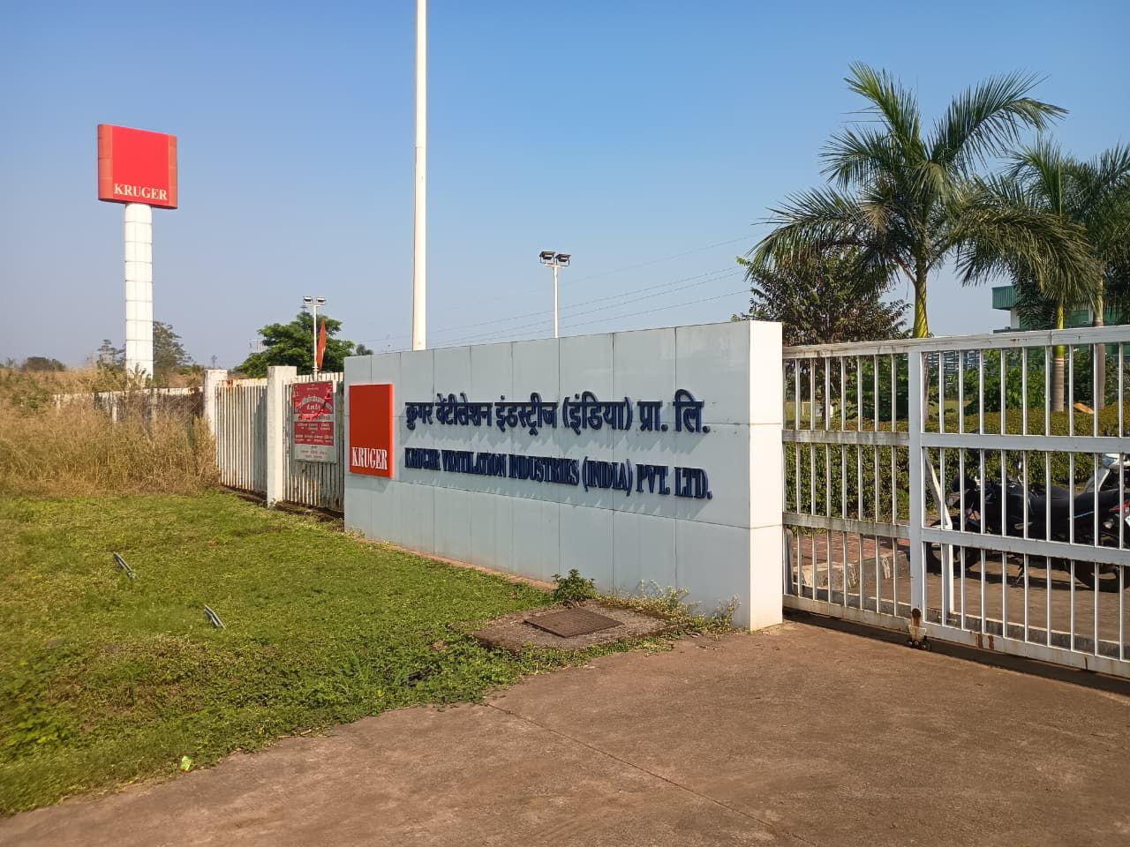

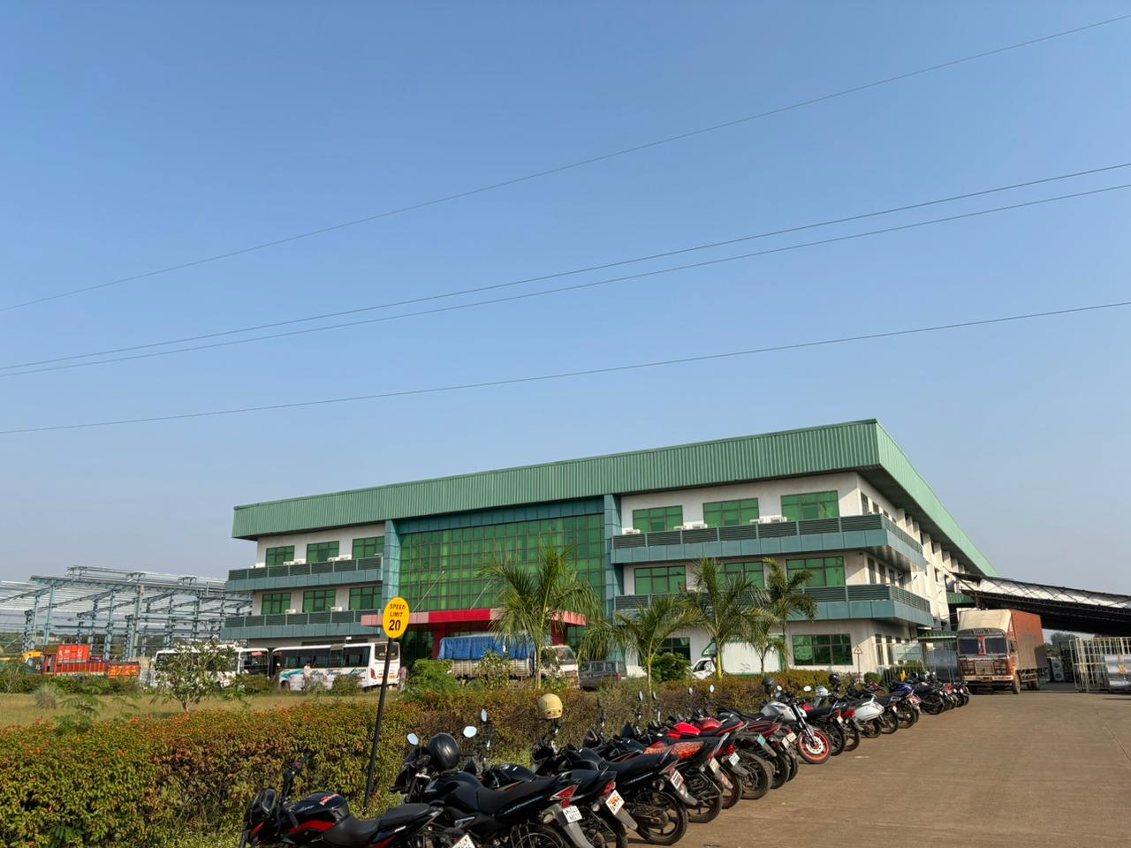

AT THE TERMINAL:-

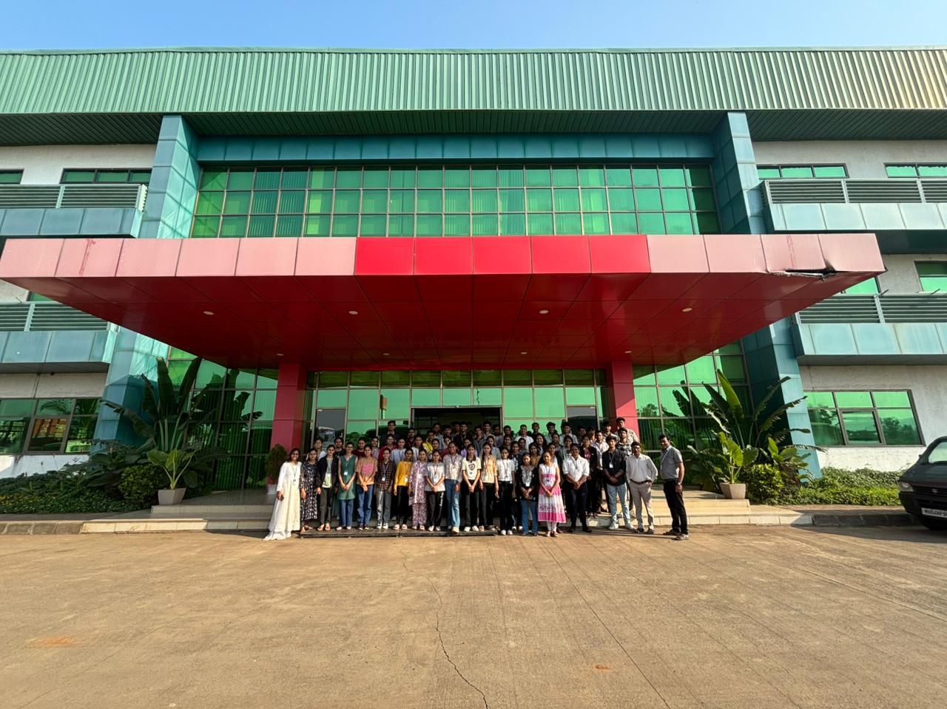

After reaching at terminal point, management team informed all students about:-
- Safety measures: Safety first Follow all instructions given by the company staff. Wear any required personal protective equipment (PPE).
- Respect the facility: Be mindful of the industrial environment and avoid touching machinery or equipment unless instructed to do so.
- Product uses and applications: About the products applications.
- Technical platform :Platform and their control on the process.
- Financial status : Financial part where they informed how billing is done with help of software.
- Ask questions: Engage with the staff to learn as much as possible about the company's processes and products.

PRODUCTION UNIT:-

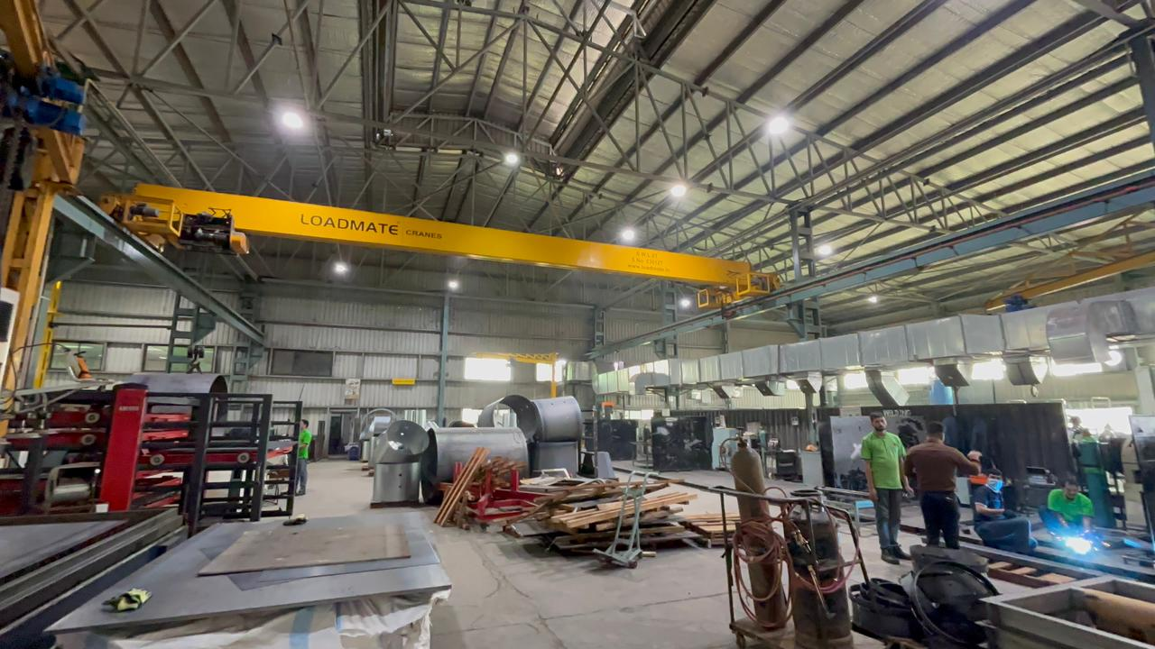

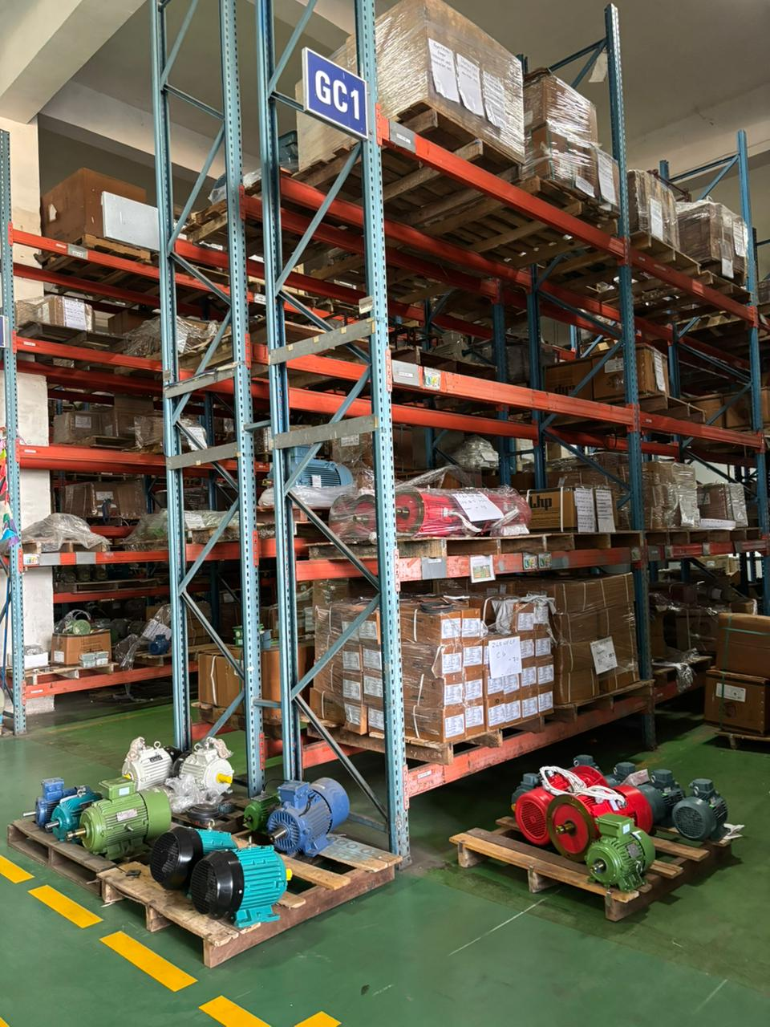

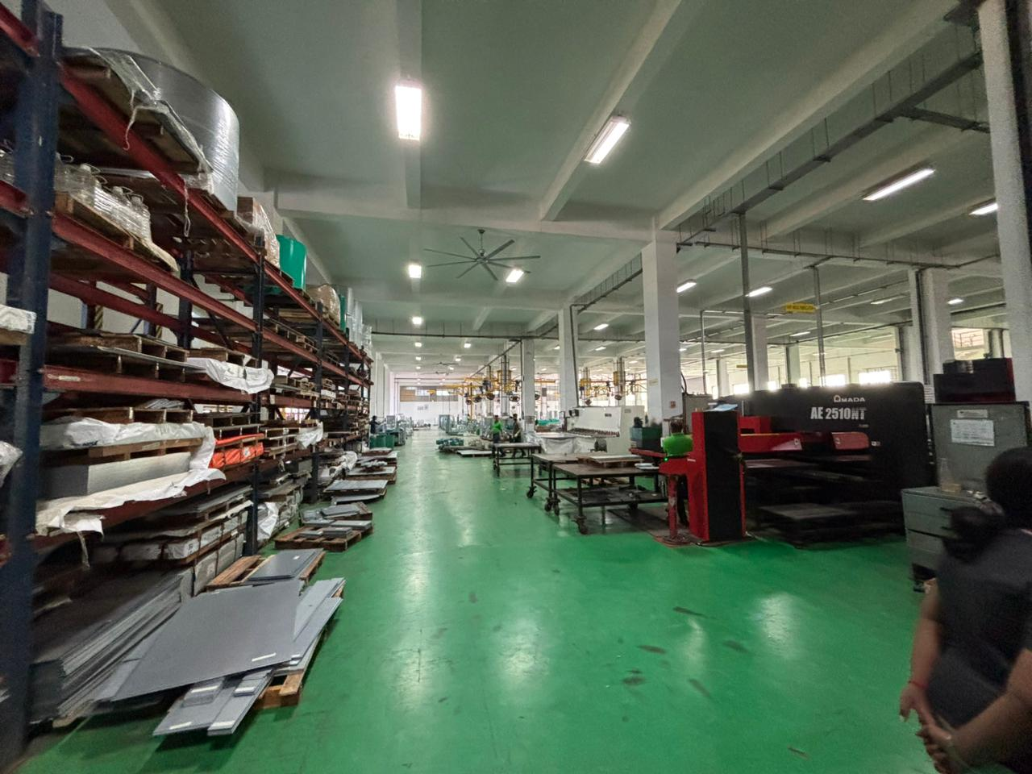

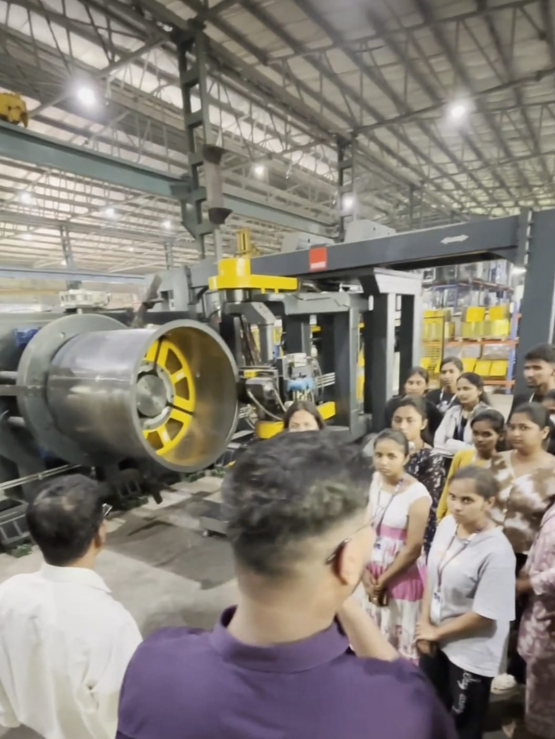

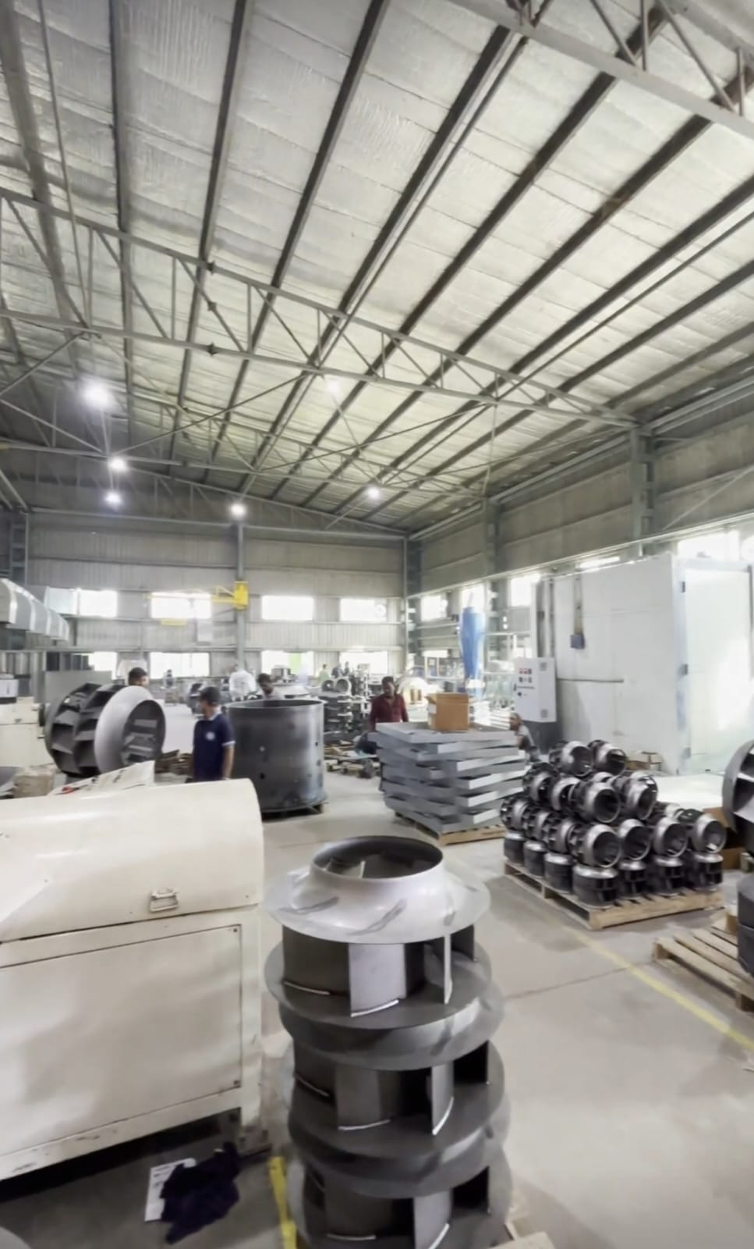
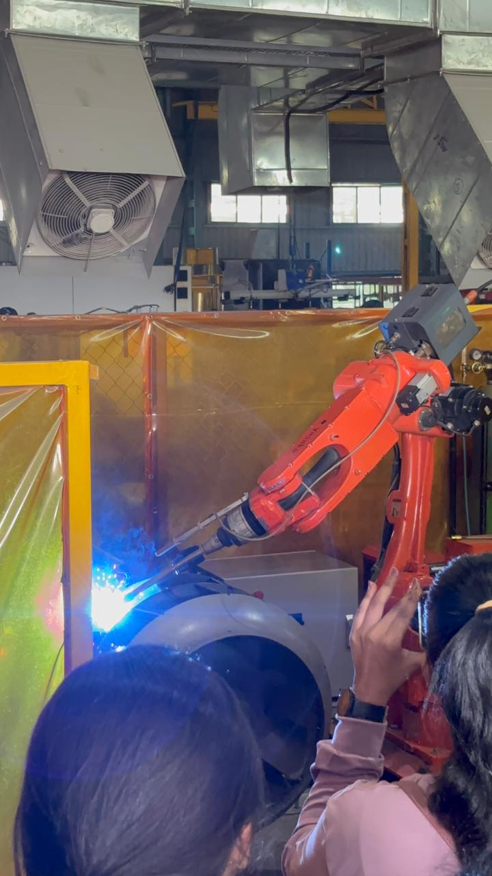

After lecture at terminal we went to container gate to watch the live process that how a product is taken in container, movement of container by cranes and placing them in ship.

Control room of terminal:-

Enable smooth paperless transactions over a single window to customers and trade at large.

- Have successfully processed over 75,244 electronic transactions and containers, since launch Cold Chain Logistics.
- Camera control of shipping process where they can zoom and read the container.
- Protection and security of container and system.
- About full speed engine and auxiliary engine, in auxiliary engine the diesel consumption is less.
- Container can’t be move without control room permission.

MOMENT OF STUDENTS WITH TEAM:-

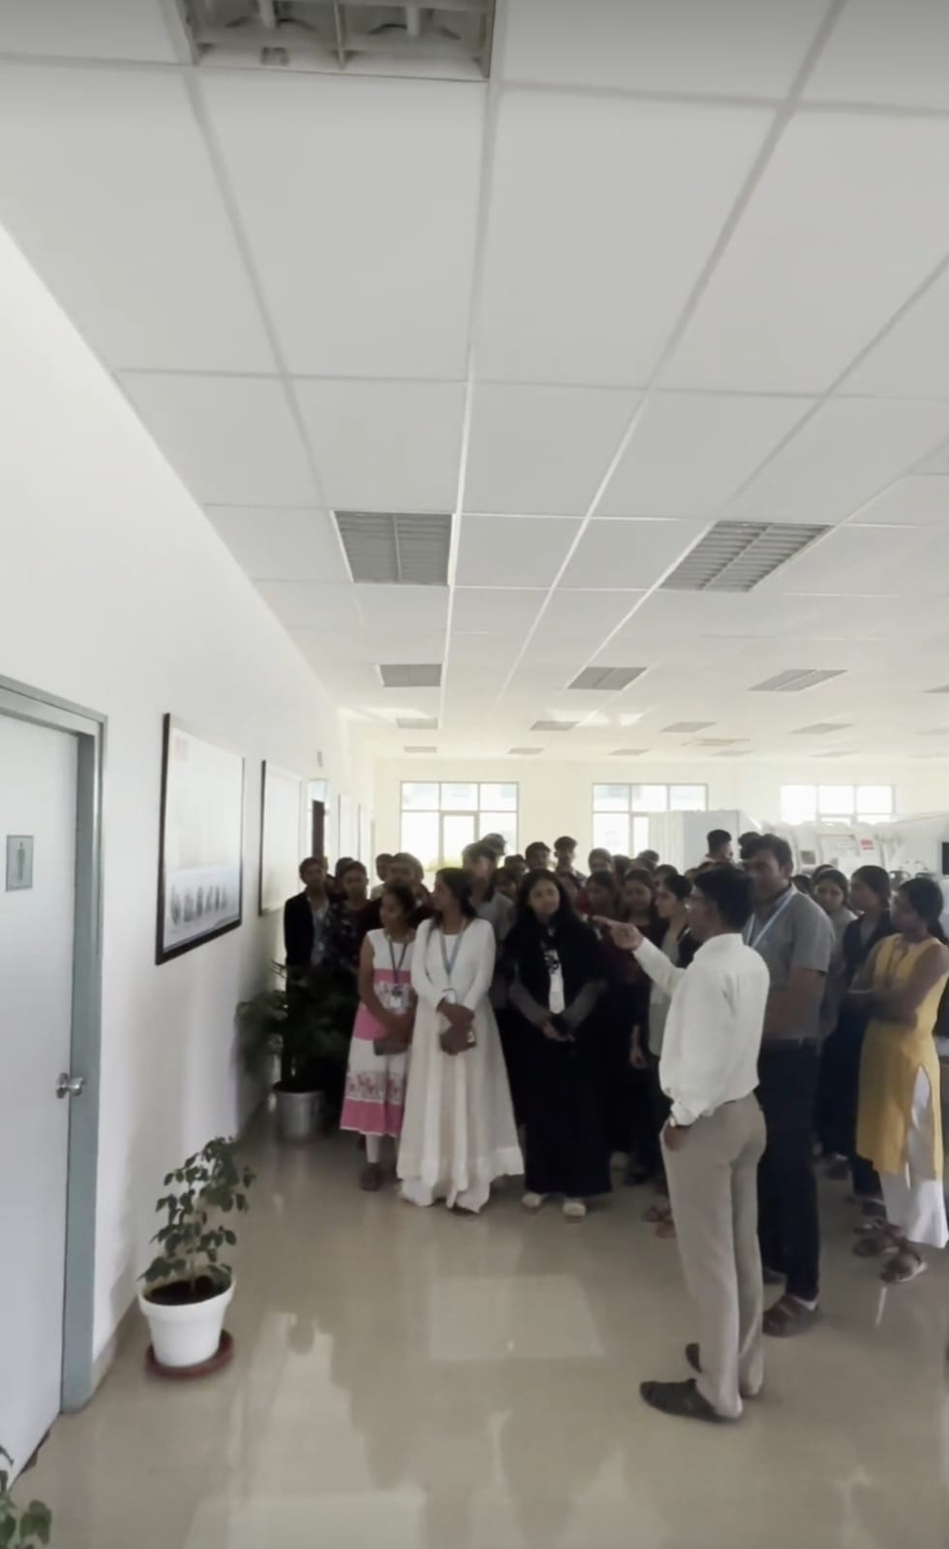

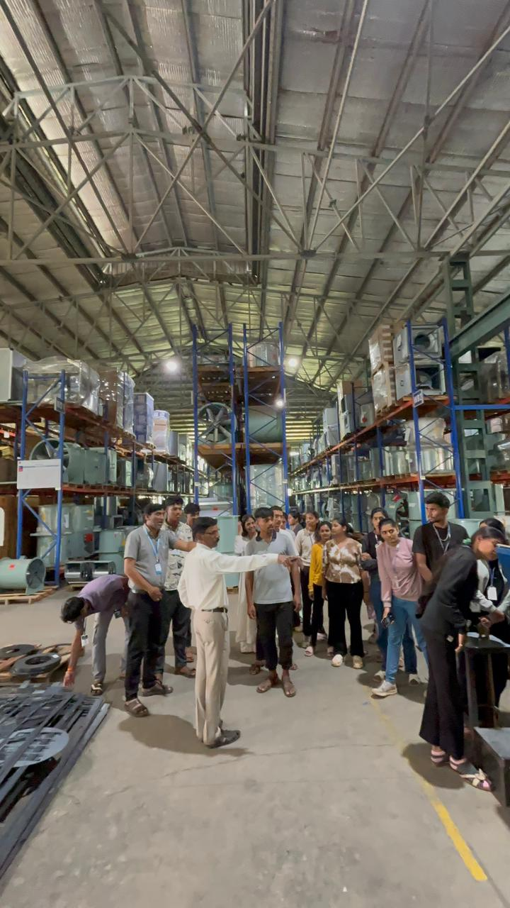

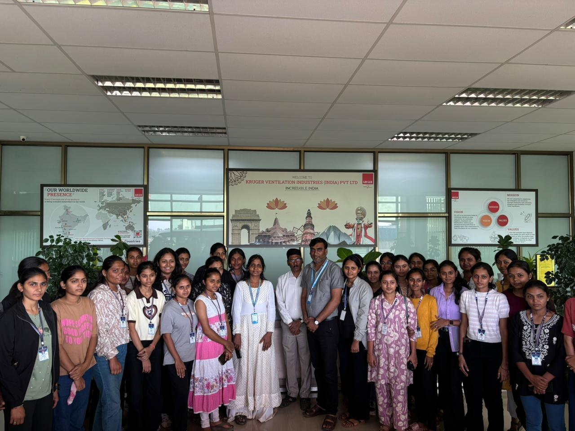

S.S.V.P.S's BAPUSAHEB SHIVAJIRAO DEORE COLLEGE OF ENGINEERING, DHULE
Department of Electronic Engineering
Sr.No. | Name Of Student | Year Appearing | Student's Contact | Parent's Contact
1 | PATIL TANAVI HARIKISAN | S.Y.E&Comp | 9975453554 | 9766453554
2 | HIRE YUKTA LAXMAN | S.Y.E&Comp | 9673789209 | 7385246243
3 | SURYAWANSHI MINAL SANDIP | S.Y.E&Comp | 7263857122 | 9284820616
4 | BHAMARE HETAL RAJENDRA | S.Y.E&Comp | 9545367393 | 8799938922
5 | PAWARA PRITI KUWARSING | S.Y.E&Comp | 7875119813 | 9665206924
6 | PATIL SHIWANI SUDHAKAR | S.Y.E&Comp | 9028740251 | 9028740251
7 | SHEWALE SAMIKSHA MANOJ | S.Y.E&Comp | 7741852472 | 9325676098
8 | PAWAR KAJAL DIPAKRAO | S.Y.E&Comp | 7741999242 | 7972735690
9 | NAVLAKHE ANJALI UMESH | S.Y.E&Comp | 9403436412 | 9404921612
10 | PATIL BHUMIKA SANDIP | S.Y.E&Comp | 9421235737 | 9307005985
11 | MOHITE PRACHETI PRADIP | S.Y.E&Comp | 9823676574 | 9834935508
12 | WAGH DHRUVIKA SAHEBRAO | S.Y.E&Comp |  | 9284707990
13 | BHAMARE VAISHNAVI NANDKISHOR | S.Y.E&Comp | 9359983568 | 9359983568
14 | PATIL VAISHNAVI SHAM | S.Y.E&Comp |  | 9699634507
15 | BHAMARE PRERNA ARVIND | S.Y.E&Comp | 9561258570 | 9405985343
16 | PATIL PREETI KANHAIYALAL | S.Y.E&Comp | 9850508152 | 9623654181
17 | BHADANE RUPAL HEMANT | S.Y.E&Comp | 9403117770 | 8421770165
18 | PITRUBHAKTA DEVYANI PADMAKAR | S.Y.E&Comp | 7276832491 | 7020437911
19 | BORASE VAISHNVI BHARAT | S.Y.E&Comp | 9322640175 | 8767747785
20 | CHAUDHARI DISHA PRADIP | S.Y.E&Comp |  | 7821903486
21 | MEGHARAJ SHUBHAM VIJAY | S.Y.Elex | 9146521677 | 8421669903
22 | RAYATE PARAG PRAMOD | S.Y.Elex | 9404752331 | 9421498023
23 | PATIL PRASHANT VIJAY | S.Y.Elex | 9420373196 | 9022193262
24 | MORE GAYATRI SATISH | S.Y.Elex | 9423374646 | 9322770399
25 | PARDESHI CHANDRIKA DIPALI | S.Y.Elex | 7350694294 | 9579355147
26 | PATIL RIYA SUNIL | S.Y.Elex | 9011760752 | 6355037211
27 | PATIL LAVANYA NIMBA | S.Y.Elex | 9359920128 | 9193599201
28 | PAWAR MAYURI VIJAY | S.Y.Elex | 8010497840 | 9284315606
29 | BAGUL NISHANT JAYANT | S.Y.Elex |  | 8010972255
30 | CHAUDHARI UDAY MACHHINDRA | S.Y.Elex | 9767948897 | 9529695655
31 | JAGTAP YASH MAHENDRA | S.Y.Elex | 9420257453 | 9834276990
32 | MAHALE JAYESH TUKARAM | S.Y.Elex | 9623115483 | 9623115483
33 | BADGUJAR NAYAN SUNIL | S.Y.Elex |  | 9552718405
34 | NERKAR NIRMAL BHATU | S.Y.Elex | 9922192470 | 9970808932
35 | SAUNDANE AVIRAJ CHOTU | S.Y.Elex |  | 7350895544
36 | JADHAV VAIBHAV LADUSING | S.Y.Elex |  | 9022607850
38 | PATIL BHAVESH DEVIDAS | S.Y.Elex | 9623085307 | 7666260924
39 | BAVISKAR SAHIL PRAVIN | S.Y.Elex | 7057237974 | 9403162761
40 | PATIL ARCHANA ATUL | T.Y.Elex | 9322345145
41 | BHADANE RIYA KETAN | T.Y.Elex | 8657412510
42 | PATIL VAISHNAVI JAGDISH | T.Y.Elex | 9699645261
43 | THAKARE BHUMIKA MAHESH | T.Y.Elex | 8805240184
44 | PATIL SHUBHANGI VIVEK | T.Y.Elex | 8767227052
45 | PAWAR GAYTRI TULSIDAS | T.Y.Elex | 8007727659
46 | PATIL JAGRUTI JAGDISH | T.Y.Elex | 9370142608
47 | PATIL MEGHA VIRDHAVAL | T.Y.Elex | 9356513552
48 | GURAV MAYUR CHANDRAKANT | T.Y.Elex | 8262959852
49 | AHIRRRAO GIRIRAJ SANJAY | T.Y.Elex | 9356987986
50 | BAGUL ADITYA RAVINDRA | T.Y.Elex | 9422035039
51 | PATIL KUNAL ATUL | T.Y.Elex | 8446291256
52 | BARI ADITYA DEEPAK | T.Y.Elex | 8446489322
53 | DEORE DNYANESH AJIT | T.Y.Elex | 9373054388
54 | BACHHAV ABHIJIT RAJENDRA | T.Y.Elex | 7507880811
55 | PATIL YASH BHARAT | T.Y.Elex | 8857033102
56 | WAGH HEMRAJ LOTAN | T.Y.Elex | 8010157326
57 | JADHAV AKSHAY RAVINDRA | T.Y.Elex | 8799960520
58 | GARDE ANKIT PRALHAD | T.Y.Elex | 9359372762
59 | BAGUL SACHIN GOKUL | T.Y.Elex | 8446076461
60 | SONAR GAURI | T.Y.Elex | 8432162168
61 | SONAR SONAL | T.Y.Elex | 9823320836
62
From,
Prof.Dipmala M.Patil
Assistant Professor
Electronics Engineering Department
Shri. Shivaji Vidya Prasarak Sanstha’s Bapusaheb Shivajirao Deore College Of Engg. Dhule, -424003(Maharashtra)
Contact No: 7620310729
Date: 20 November 2025

To,
Mr.Santosh Sir
H.R.
Kruger Ventilation Indudtries (India) PVT.LTD.
Kruger Centre.Mumbai-Nashil Highways,Kalamgaon, Shahapur, Thane 421601, Maharashtra,India
Subject: Letter of Gratitude for the Engineering Students' Industrial Visit
Respected Mr.Santosh sir,
On behalf of the S.S.V.P.S’s B.S.Deore College of Engineering,Dhule Department of Electronics Engineering I would like to extend our sincerest gratitude to you and your team at Kruger Ventilation Industries (India)PVT.LTD.for hosting our engineering students on 16 November 2025. The visit provided an invaluable practical learning experience that significantly complemented their theoretical knowledge in manufacturing processes,automation, quality control and experiencing industrial environment
The students were particularly impressed by the advanced automation technology used in your production line, the company's approach to sustainable engineering, the Q&A session with your engineering team. These insights offered a realistic perspective on the industry's best practices and daily operations, which is difficult to replicate within a classroom setting.
We are incredibly grateful for the time and effort your staff put into organizing and conducting the tour. Their professionalism, enthusiasm, and willingness to share their expertise were truly inspiring for our future engineers.
This experience has undoubtedly broadened their horizons and helped them connect their academic studies with real-world applications. We believe such interactions between academia and industry are crucial for nurturing job-ready talent.
Thank you once again for your generosity and for providing this exceptional educational opportunity. We hope to maintain this valuable relationship and potentially collaborate on future initiatives.
Sincerely,

