Department of Management Studies
Activity Report
- Submitted by: Mr. Kamal Prakashlal Wadhwani
- Date of Submission: 09/01/2025
- College Coordinator : Mr. Kamal P. Wadhwani

Activity Type | University Level Research Convention (Phase-II)
Activity Title | Aavishkar 2025
Date of Activity | 30 & 31/12/2025
Duration | Two Days
Venue | K.B.C. North Maharashtra University Campus, Jalgaon
Organizers | K.B.C. North Maharashtra University, Jalgaon
Target Audience | Shortlisted UG, PG, and PPG Research Students from District Rounds
Brief Description of the activity | Following the District Level competition at Dhule, 03 teams from our MBA department were shortlisted to participate in the University Level (Phase-II) Aavishkar at Jalgaon. The event was a rigorous two-day selection process. On Day 1 (Dec 30), all 3 teams participated in the Poster Presentation. Based on merit, 02 teams were further selected for Day 2 (Dec 31) to deliver a Podium Presentation (PPT) before a panel of expert judges. This final round was the qualifying stage for the State Level Convention.
Objectives | - To present high-quality research at the university forum.  - To compete for a spot in the Maharashtra State Level Aavishkar Team.  - To refine research presentation skills through the Podium (PPT) round.  - To engage with top-tier academic experts and university evaluators.
Key Rounds | Day 1: Poster Presentation (All 3 teams participated)  Day 2: Podium Presentation (02 teams selected for final defense)
Administrative Framework | Under the Patronage of Vice-Chancellor Prof. Vijay L. Maheshwari and University Coordinator Dr. Navin D. Dandi.

Resource Person(s)  (If applicable) | University-appointed Jury Members and Coordinators
Outcomes and Learning Points | - Achievement: Reaching the Podium Round (Day 2) placed our students among the top researchers in the university jurisdiction.  - Expert Defense: Students gained invaluable experience in defending their research via PowerPoint in a formal academic setting.  - Skill Development: Despite not qualifying for the State Level, the students mastered advanced research methodology and presentation techniques.  - Benchmarking: Participants identified the high standards required for State Level selection, providing a roadmap for future research projects.
Participation & Performance Summary | - Phase-II: Day 1 (Poster Presentation Round) The following three teams represented the department at the University Campus:  Team 1: Prajakta Gokul Makade & Pooja Mahendra Sonar (PGP2-99)  Team 2: Sayali Jagdish Suryawanshi & Preeti Bhanudas Koli (PGP2-100)  Team 3: Poonam Sudhir Bhardwaj & Krutika Bhagwan Neve (PGP2- 103)  - Phase-II: Day 2 (Podium Presentation Round) Based on the scores from Day 1, the following teams were shortlisted for the final qualifying round:  Team 2: Sayali Jagdish Suryawanshi & Preeti Bhanudas Koli (PGP2-100)  Team 3: Poonam Sudhir Bhardwaj & Krutika Bhagwan Neve (PGP2- 103)  University Result Link: https://nmu.ac.in/Portals/0/Avishkar/Avishkar%202025/Final%20Result%20round%201st.pdf  - Final Summary Out of the five teams that originally participated at the District Level, three teams qualified for the University Level. From those three, two teams successfully advanced to the final Podium Presentation stage. While our students were not selected for the State Level this year, reaching the final university selection round is a significant academic milestone for the department and the students involved.

Photos  GPS Location | (Best wishes for University Level Aavishkar)  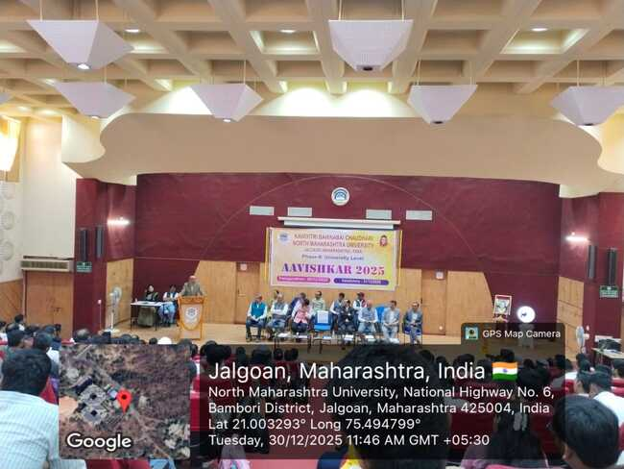  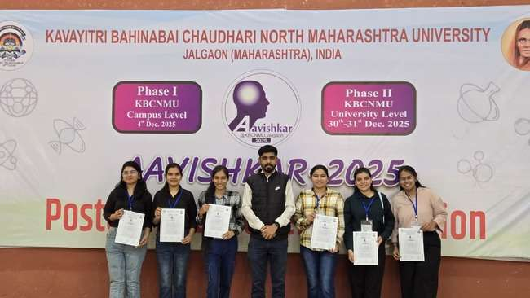  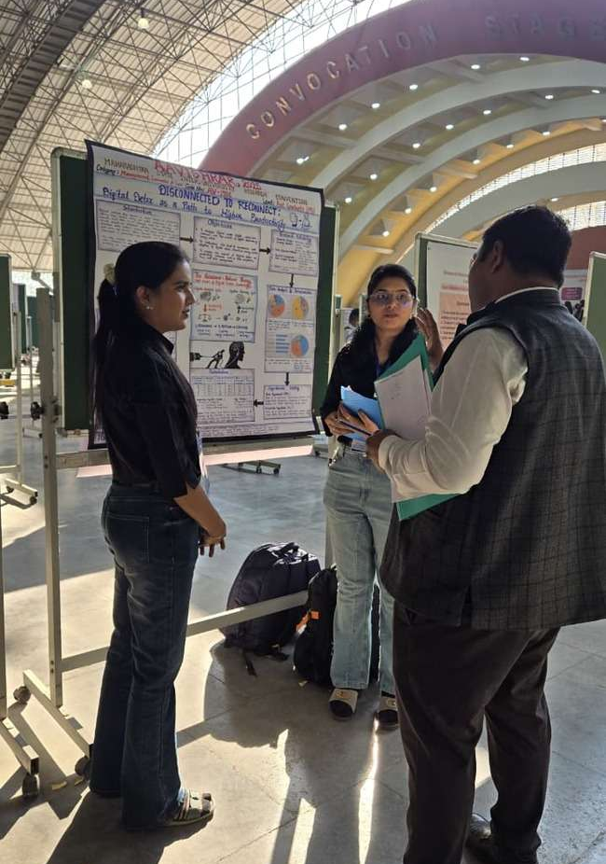  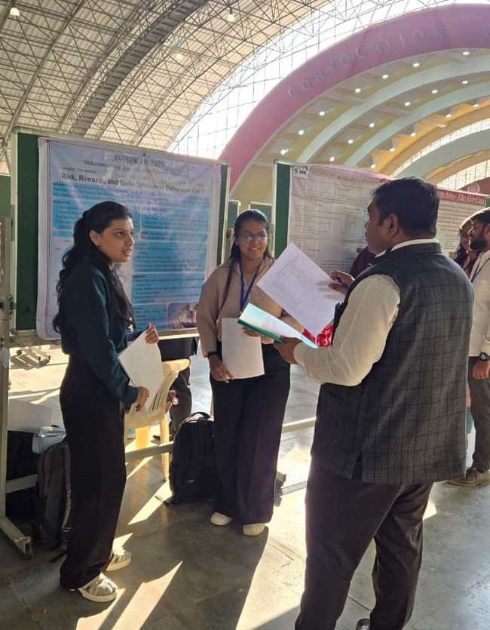  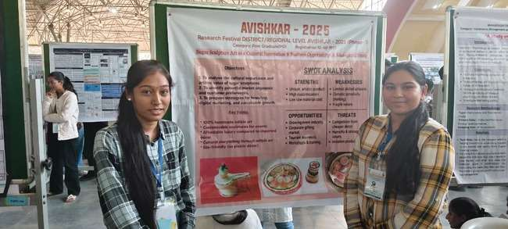  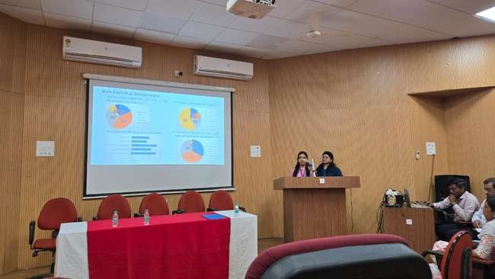  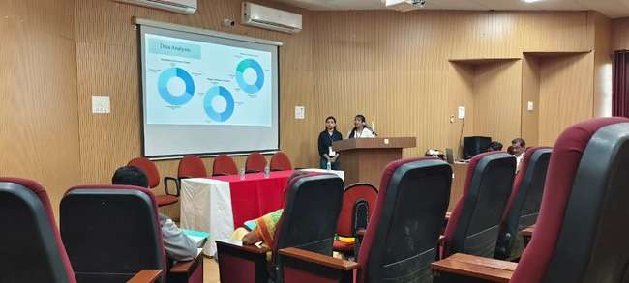  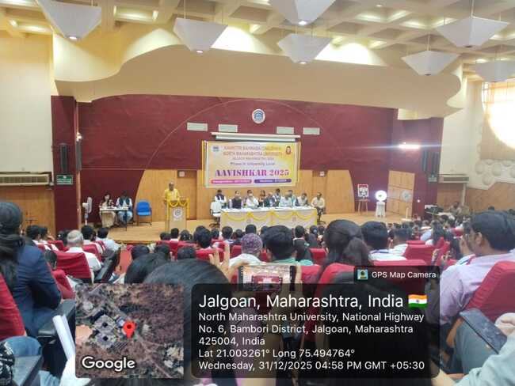

Supporting Document:  Certificates of Participation | 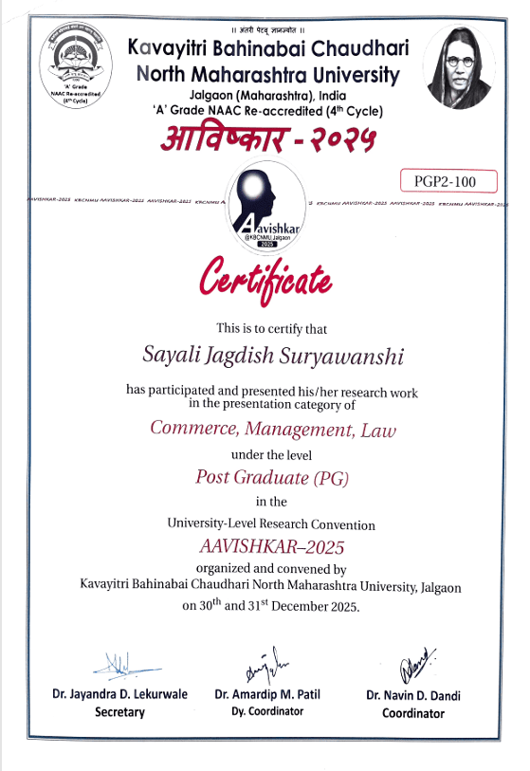  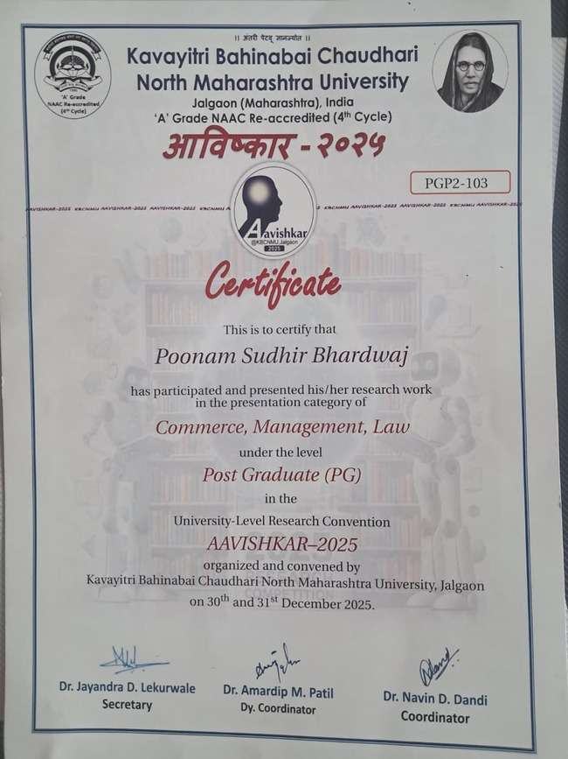  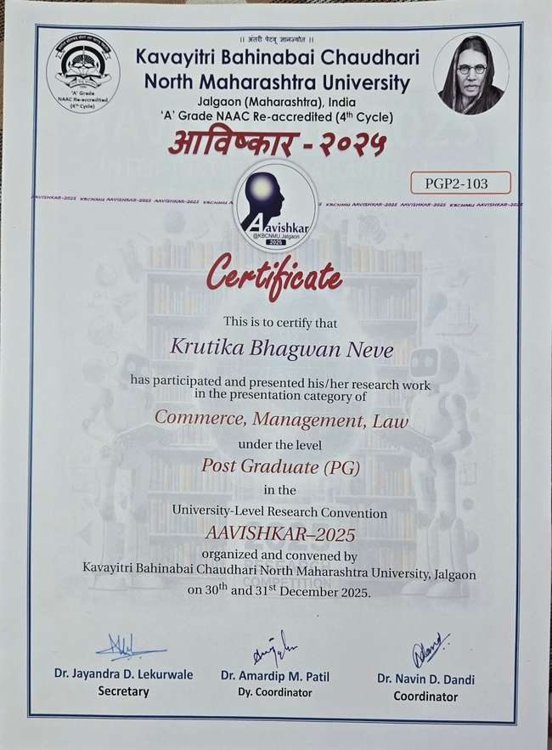  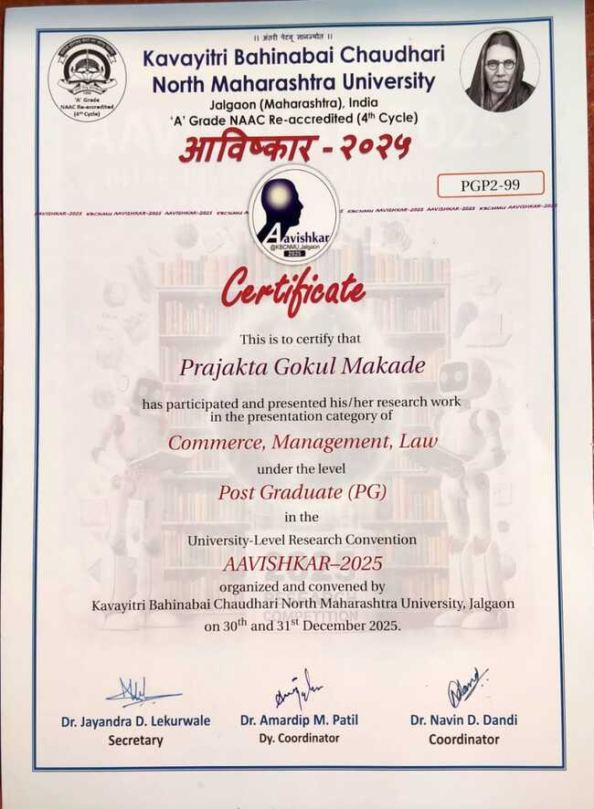  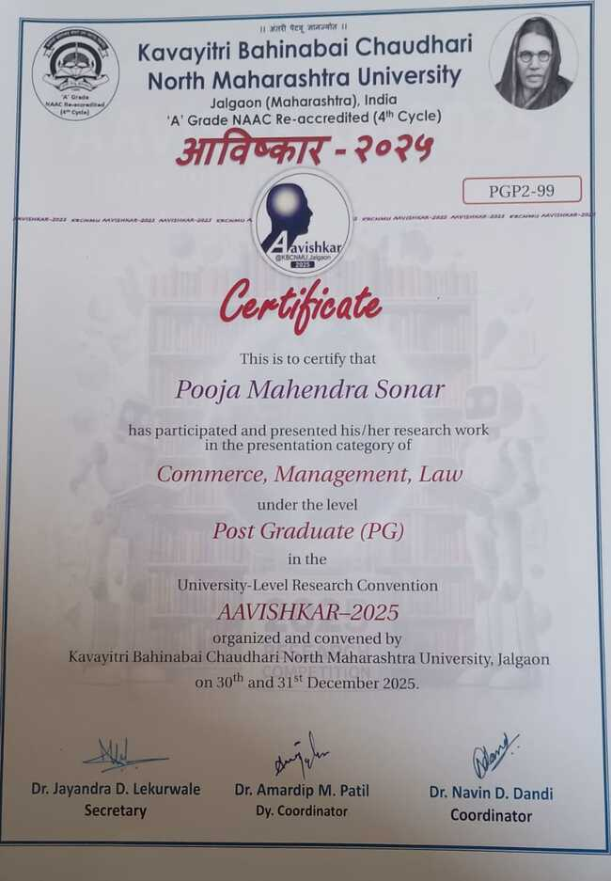

Flyer/  News | 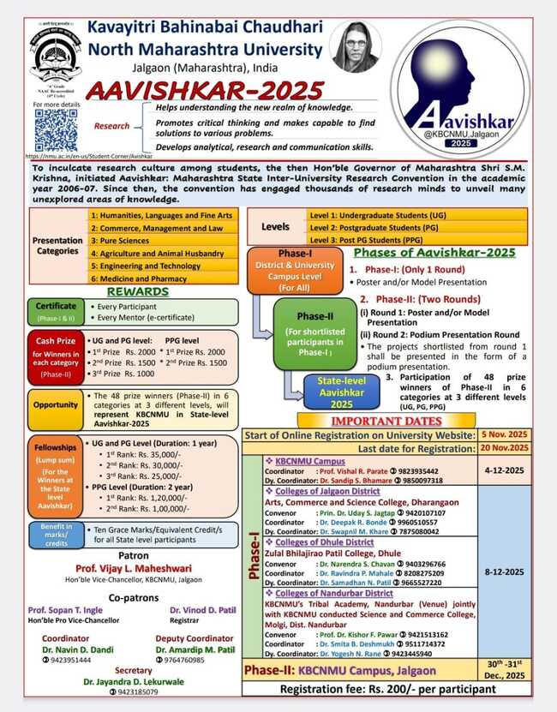  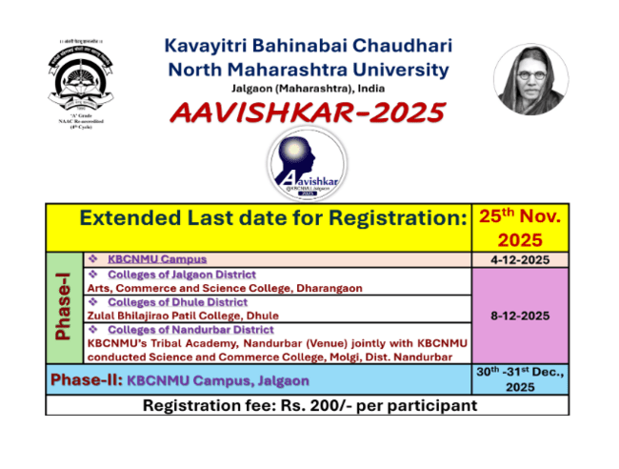

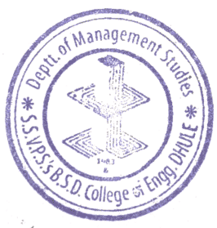

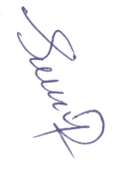
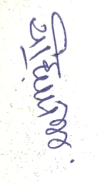

Mr. K. P. Wadhwani Dr. Y. A. Patil
College Co-ordinator HOD

